FACILITATION AND MEDIATION OF ACTIVE LEARNING

LEARNER GUIDE

Module # | 234201000-KM-04
NQF Level | level 5
Notional hours | 120
Credit(s) | Cr 12
Curriculum Code | 234201000
SAQA QUAL ID | 97542
Qualification Title | Occupational Certificate: Early Childhood Development Practitioner : L4-131 credits

CONTACT INFORMATION:

Name
Contact Address
Telephone (H)
Telephone (W)
Cellular

TABLE OF CONTENTS

PURPOSE OF THE QUALIFICATION 4
QUALIFICATION RULES 6
EXIT LEVEL OUTCOMES 8
ENTRY REQUIREMENTS: 9
ARTICULATION OPTIONS 10
ASSESSMENT REQUIREMENTS 11
PROVIDER ACCREDITATION REQUIREMENTS FOR THE MODULE: 12
SECTION 1: M-04-KT01: Facilitation and mediation in early childhood development (100%) 14
1.1 Facilitation and mediation of all children's learning 14
1.2 Adult-directed and child-initiated learning 30
1.4 Types and features of basic resources and teaching aids, including adapted equipment 67

PURPOSE OF THE QUALIFICATION
Purpose:
The purpose of this qualification is to prepare a learner to operate as an Early Childhood Development Practitioner.
An Early Childhood Development Practitioner plans and prepares early childhood activities, facilitates and mediates learning, observes and assesses the progress of children, and reflects on learning in an inclusive, play-based environment to support holistic development of children (from conception - school going) in different centre-based or non-centre based settings.

A qualified learner will be able to: • Plan and prepare broad-phase learning environment and stimulating activities that meet the holistic needs of all children in centre-based or non-centre-based settings.
• Facilitate and mediate all aspects of the daily programme in a centre-based or non-centre based setting.
• Observe, assess and record each child's progress according to the age and stage.
• Compile a report of each child's progress.
• Maintain and promote the well-being, health, nutrition, safety and protection of children.

Rationale:
The Occupational Certificate: Early Childhood Development has been designed to meet the needs and interests of the early childhood development sector in a variety of settings and contexts with an inclusive focus on education, health and safety issues, amongst others. There is a vast need for early childhood development services and it is critical that the field must be served by competent practitioners. In order to meet the needs at early childhood development level, it is important to be able to identify and recognise competent early childhood development practitioners who are able to work in centre-based and non-centre-based early childhood development settings.

This qualification will provide a means to give recognition to practitioners at an entry level, thus making it possible for practitioners to increase their employment prospects within the Department of Basic Education. The Department of Social Development, through the registration of early childhood development centres and/or sites, may also provide business opportunities to successful practitioners who may wish to establish early childhood centres and/or sites. It will also provide access to a recognised career path and at the same time provide the field with suitably qualified professional practitioners.

The qualification will provide opportunities to people who wish to enter and/or continue learning in the early childhood development field, which include the employed, under-employed but not qualified, and school leavers. Every child has the right to high-quality, holistic education and care which forms the critical foundation for further development and learning from childhood into adulthood.

This necessitates the universal availability of high-quality early childhood development and education as a vital strategy to yield personal and long-term benefits to individual children, their families and the society at large.

Early childhood development is an essential component of economic development within the framework of child care services. Changing social and economic needs require parents to enter the labour market. Therefore quality early childhood development service provision is required to meet growing demands in the country, both in urban and rural settings.
.

QUALIFICATION RULES
This qualification is made up of the following compulsory Knowledge Modules, Practical Skill Modules and Work Experience Modules totalling 131 Credits:

Knowledge Modules: 43 Credits:
• 234201000-KM-01, Introduction to the early childhood development sector, at NQF Level 4, 4 Credits.
• 234201000-KM-02, Theories and Perspectives of Child Development, at NQF Level 5, 6 Credits.
• 234201000-KM-03, Planning and Programme Development in early childhood settings, at NQF Level 4, 8 Credits.
• 234201000-KM-04, Facilitation and mediation of active learning, at NQF Level 5, 12 Credits.
• 234201000-KM-05, Observation and assessment in early childhood development, at NQF Level 4, 4 Credits.
• 234201000-KM-06, Promotion of health, safety and well-being of children, at NQF Level 4, 6 Credits.
• 234201000-KM-07, Administration for early childhood development services and programmes, at NQF Level 3, 3 Credits.

Practical Skill Modules; 43 Credits:
• 234201000-PM-01, Plan and prepare inclusive educational activities and routines using an approved programme based on the curriculum framework, at NQF Level 4, 12 Credits.
• 234201000-PM-02, Facilitate and mediate active learning in an integrated and holistic learning programme, at NQF Level 5, 9 Credits.
• 234201000-PM-03, Observe, assess, record and report each child's progress according to the age and stage, at NQF Level 4, 4 Credits.
• 234201000-PM-04, Support and promote the health, nutrition, safety, protection and well-being of children, at NQF Level 4, 12 Credits.
• 234201000-PM-05, Build and maintain collaborative relationships with parents and other service providers, at NQF Level 4, 3 Credits.
• 234201000-PM-06, Prepare and maintain administrative systems, at NQF Level 3, 3 Credits.

Work Experience Modules; 45 Credits:
• 234201000-WM-01, Learning programme and routines planning and preparation process, at NQF Level 4, 13 Credits.
• 234201000-WM-02, Processes of facilitating and mediating the learning programme in a variety of contexts, at NQF Level 4, 15 Credits.
• 234201000-WM-03, Processes of observation, assessment, recording and reporting on children's learning and development, at NQF Level 4, 7 Credits.
• 234201000-WM-04, Processes and procedures of promoting the health, nutrition, safety, protection and well-being of children in an early childhood development setting, at NQF Level 4, 10 Credits.

EXIT LEVEL OUTCOMES
1. Plan and prepare broad-phase learning environment and stimulating activities that meet the holistic needs of all children in centre-based or non-centre-based settings.
2. Facilitate and mediate all aspects of the daily programme in a centre-based or non-centre based setting.
3. Observe, assess and record each child's progress.
4. Compile a report of each child's progress.
5. Maintain and promote the well-being, health, nutrition, safety and protection of children.

Occupation Regulation
All trades are regulated by the Department of Higher Education and Training (DHET) through the National Artisan Moderation Body (NAMB). To become a qualified artisan you have to pass a trade test at a national trade test centre that is accredited by the Quality Council for Trades and Occupations (QCTO). All national trade test centres are quality assured and recommended for accreditation by the NAMB.

ENTRY REQUIREMENTS:

LEARNING ASSUMED TO BE IN PLACE AND RECOGNITION OF PRIOR LEARNING
Recognition of Prior Learning (RPL):
RPL for access to the external integrated summative assessment: Accredited providers and approved workplaces must apply the internal assessment criteria specified in the related curriculum document to establish and confirm prior learning. Accredited providers and workplaces must confirm prior learning by issuing a Statement of Results or certifying a Work Experience Record.

RPL for access to the Qualification: Accredited providers and approved workplaces may recognise prior learning against the relevant access requirements.

Entry Requirements: • National Certificate Vocational (NCV) at NQF Level 3.
Or
• Any other NQF Level 3 qualification.

ARTICULATION OPTIONS

Horizontal Articulation:
• Further Education and Training Certificate in Early Childhood Development, NQF Level 4, SAQA ID: 58761.

Vertical Articulation:
• National Certificate in Early Childhood Development, NQF Level 5, SAQA ID: 58761.
• National Diploma in Early Childhood Development, NQF Level 5, SAQA ID: 64650.

ASSESSMENT REQUIREMENTS
Integrated Formative Assessment: The skills development provider will use the curriculum to guide them on the stipulated internal assessment criteria and weighting. They will also apply the scope of practical skills and applied knowledge as stipulated by the internal assessment criteria. This formative assessment leads to entrance into the integrated external summative assessment.

Integrated Summative Assessment:
The external summative assessment will be a trade test conducted in terms of Section 26 D of the Skills Development Act through an evaluation of written and practical tasks covering critical aspects of the trade and conducted in a simulated environment at an assessment centre accredited by QCTO by an assessor registered by National Artisan Moderation Body. The assessment will take place over a minimum of 2 days.

PROVIDER ACCREDITATION REQUIREMENTS FOR THE MODULE:

Physical Requirements:
• Training venue/classroom, chairs, desks and tables
• Training material and resources

Human Resource Requirements:
• The trainer must have an NQF Level 5 or higher Early Childhood Development Qualification or equivalent
• Registered Assessor with ETDP SETA is a recommendation
• The trainer with facilitation skills is a recommendation
• Trainer to learner ratio: 1:30 (Maximum)

Legal Requirements:
• Legal Entity
• Accredited skills development provider with ETDP SETA
• Compliant with Occupational Health and Safety legislation and requirements

Exemptions
None

TOPIC ELEMENTS TO BE COVERED INCLUDE:
- The main focus of the learning in this Knowledge Module is to build an understanding of the concepts of facilitation and mediation in early childhood development settings.
- The learning will enable learners to demonstrate an understanding of:
- • KM-04-KT01: Facilitation and mediation in early childhood development (100%)

SECTION 1: M-04-KT01: Facilitation and mediation in early childhood development (100%)

Learning Outcome

At the end of this section, learners should cover:

KT0101 Facilitation and mediation of all children's learning

KT0102 Adult-directed and child-initiated learning

KT0103 Supporting language, literacy and maths in an early childhood education setting

KT0104 Types and features of basic resources and teaching aids, including adapted equipment

Facilitation and mediation of all children's learning

Your role in the ECD service
Once you qualify as an ECD practitioner, you will be part of the ECD service and will have to uphold professional standards of practice. To do this well, and to contribute to the service nationally, you should keep building your skills and knowledge.

To summarise the process of feedback on facilitation, consider the following steps:
- Record the feedback you have received
- Take time to reflect on the changes you can make to your facilitation
- Implement the changes when you next have an opportunity to engage in a similar activity
- Make recommendations from what you see as the result of those changes

DEFINITION
Recommendations: proposals for changes to improve something.
An example is that you might recommend that the timetable for use of the outdoor area could be reviewed, to make it possible for different groups to use the outdoor area at different times.

The role of the ECD service in education in South Africa

Children’s literacy levels at primary schools in South Africa are currently poor. To improve them, children need a solid foundation for their early development and to have a good relationship with learning. The Early Childhood Education service in South Africa plays a vital role in preparing children for formal schooling, introducing them to stimulating activities, teaching them social skills, building their coordination, cognitive skills, moral, creative and language skills, introducing them to books, working in groups, becoming independent and becoming confident people.

To keep standards of early childhood education high, or to improve them where they are low, your reflection on your facilitation can add to the pool of knowledge available to other practitioners. Your role is to keep your own standards of practice high, to generate new knowledge and to share your expertise about facilitation. If all practitioners do this, the growth of skills and expertise will have a positive effect on the development of all the children in the ECD center.

To be sure you are providing a high-quality ECD service, (for the sake of children’s rights), you should make a habit of reflection, evaluation and improvement on the quality of your facilitation. When you cooperate with other ECD practitioners to do this, you will all raise the general standard of early childhood education and also positively grow the literacy levels in primary schools, as a result. Use not only reflection, but also various other sources for your learning: workshops, journal articles, books, TV or radio programmes about ECD, other ECD practitioners, and your own questions. It is very useful to discuss case studies with colleagues as this is the way to learn the principles, rules, exceptions and general background of ECD work.

Problem solving to improve standards of facilitation

Don’t be afraid to try something new; use your store of experience, insight, knowledge of the children and of your own strengths, to try out a new skill or change one you are used to. Be willing to try, make mistakes, and try again. Use the feedback and your reflection to record your conclusion about what needs to be done, then simply do it.

- Stop to check what is happening and take stock of the situation.
- Look closely at what is going on, reflect on it so that you understand it.
- Make the decision about what corrective changes to implement, and keep observational records about these.
- Put the changes into action in your group.
- Again, stop and check that the new strategy is working.
- Share the information so that everyone may benefit.

Problem solving steps

Record recommendations and share them
When your facilitation is evaluated by an observer, this provides you with a kick-start to changing the techniques, attitudes and behaviours that need to change. The next step is to build on your strengths when you try out new attitudes and skills. Finally, you should record the positive changes as recommendations for action, for other ECD practitioners to benefit from your experience.

Write your recommendations in simple clear language. They may become part of the ECD knowledge base, so be as specific as possible about the behaviour, attitude, knowledge or skill you are addressing. Keep your sentences short. Future facilitators will rely on your recommendations to improve their own facilitation. File your recommendations in a logical way for easy access in the future.

In this study guide you will learn how to carry out some of your roles and responsibilities as an ECD practitioner with babies, toddlers and young children. To do this you need to know about the Revised National Curriculum Statement, Outcomes-Based Education and the Foundation Phase. You also need to learn about how to use developmentally appropriate learning activities, manage and communicate with children in a sensitive and encouraging way, how to model life skills and ensure that development takes place in a holistic way. You will also learn the value of reflecting on your own practice, and the importance of using feedback to improve your facilitation skills.

Before you begin, spend some time familiarising yourself with the structure of each topic. As you work through this course, think of the symbol of a tree: each topic represents one part of the tree: a root, a trunk, a branch, a leaf. Just as a tree cannot grow and thrive if it is missing its roots or trunk or branches, so you will need the information in each topic to build your skills and knowledge. Enjoy the course and give it your best effort, for your own success and for the sake of the young children in your care. And remember that each year a tree gets new leaves – so continue to add to your knowledge constantly.

In this unit you will learn how to use a holistic approach in facilitating your ECD centre’s activities. This means paying attention to the body and mind of the baby, toddler or young child, to ensure that he or she develops happily and healthily in your care. Your knowledge of child development is essential but not enough; you also need to understand the child’s family and cultural background, and have a warm, caring approach to ensure that the child has a sense of trust and comfort in your presence. To make a success of facilitating for the child’s development, you need two things: an understanding of the child as a growing person, and a happy, positive attitude towards both the child and yourself as facilitator.

Your programme will support children in their growth and in their progression to meet developmental milestones, but this will happen as a byproduct of a broader, more rounded approach that encourages all kinds of skills to develop through practise and stimulation.

Children begin to master skills when they are developmentally ready to do so, and not in chunks of skills according to a schedule. Activities are developmentally appropriate when they fit with children’s needs and abilities. You need to be sensitive to the small and varied accomplishments the children are making, which contribute to larger clusters of skills and abilities; for example, on Tuesday you notice that Neyo (6) can pour juice for his friend without spilling, which means he has the coordination and concentration to manage a whole range of games and tasks. Emphasise the positive allowing of play and learning, rather than coaching and forcing children to create products.

Having fun is the easiest way to learn something. Make sure you provide activities that are creative and exciting, drawing on the ideas, actions, and preoccupations of the age group you are working with. Their developmental age must be the guiding factor in preparing your learning programme and in guiding your own expectations and responses.

A holistic approach includes fun

Try to find activities that have the right balance of stimulation and fun, and provide a context that the child will quickly respond to. When you begin your preparation of the programme of activities, think of the words, ideas and interest focus that the children have been using in the past few days, and identify a topic or theme that will catch their interest. Be careful to present the theme at a level that the children can understand, yet still be curious to find out more about.

When you look at a new resource or activity, consider the whole child, who needs not only to develop properly but also to be involved in something meaningful and familiar. Figure 1.1 shows this interlinked relationship between the requirements for a good activity.

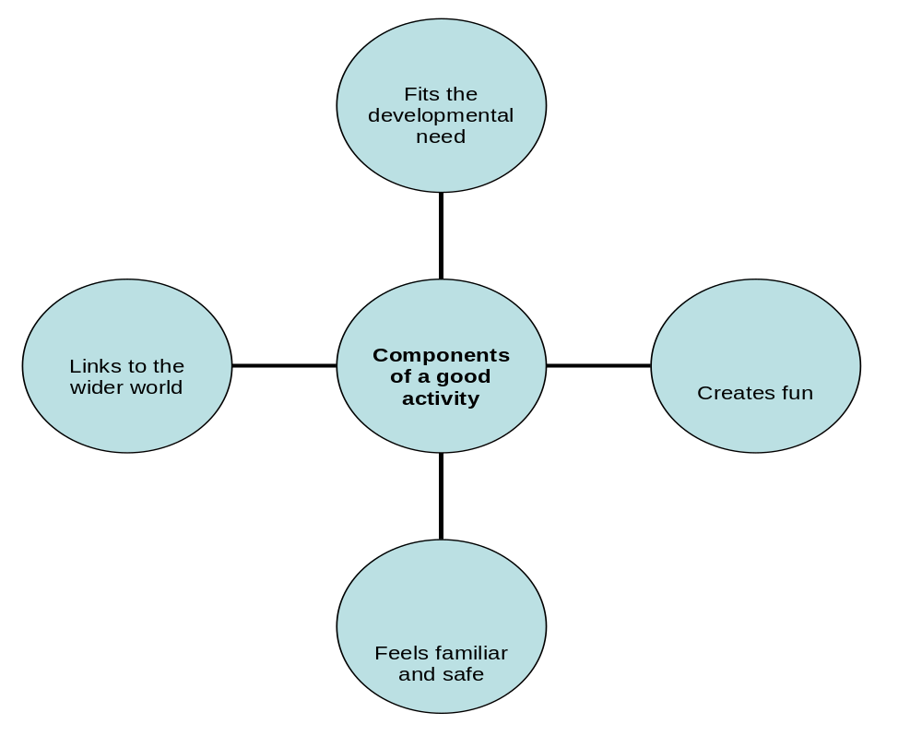

Case study: An under-resourced ECD centre
In a container in her back yard, Linda runs an ECD centre for ten young children, including three babies aged 6 months, 8 months and 11 months. She has a few cardboard boxes, some wooden toys and blocks, three story books, mattresses for naps and nappy changes, a nappy bucket, a cooler box for bottles and medicine, and outside she has a sandpit, a few tyres that the children roll and push, a vegetable patch with spinach and carrots, an outside tap with clean water, and a drop toilet. She has one assistant who comes to help her every morning from 8am to 12pm.

Linda plans her day to make the most of the assistant’s help, with structured activities (mixed with free play times) in the mornings. After 12pm she gives the children their lunches, they have nap time and then free play in the afternoon. The mornings are for structured activities, as well as free play times. With her limited resources she has the following activities to choose from:
- sand and water play outside
- boxes and mattresses on their sides make spaces and play houses
- at the end of the day the boxes become containers for toys
- the vegetable patch allows the children some healthy vegetables and also to participate in watering, weeding, observing plants growing, and generally observing nature and the seasons
- the children must take turns with the wooden toys
- the tyres and boxes can be used to create an obstacle course outside
- Linda not only reads from the three story books, she also makes up songs and new stories using the pictures to imagine new situations
- Linda and the assistant share all the skills and stories they learnt in their own childhoods, with the children

The main ingredients in Linda’s success in meeting the children’s needs, are:
- her daily observation of what the children accomplish, so that she can gradually make activities more difficult, to extend their skills
- her imagination and willingness to share stories
- her careful planning and structuring of the environment with what she has available
- her awareness of the importance of safety and stimulation, structure and free play
- her willingness to keep learning
- her ongoing search for new resources at home, for example, pictures cut from newspapers and pasted on card to make puzzles, or cast-off clothes or hats which she brings to the group for dressing up games.

Linda will benefit from formal learning to understand the developmental needs of the children more precisely, but she is already providing stimulation, fun, a sense of security and a safe space for exploration and learning.

What quality of facilitation promotes development?
The quality of facilitation that promotes the holistic development of babies, toddlers and young children, is that of nurturing warmth. By having a nurturing and emotionally warm tone in your approach to the children, you provide a fertile foundation for their sense of security and self-acceptance. The child feels free to play, explore, make mistakes and try again without fearing failure, in such a climate of warmth. His self-image grows, he feels respected, can show initiative and try out new ideas, and feels free to express his opinions.

Does nurturing mean there are no rules and limits? No, the opposite is true – the child experiences being cared for by rules and limits too, as they provide structure, fairness, and containment. But the warm and caring attitude should come first, and the rules should be fitted into that, so that the child feels heard and understood, and that his needs are being met. He then feels no anxiety about obeying a set of rules. The warm atmosphere allows children to succeed as they have a sense of inner security, and can do well at their particular level of skill.

Ways to be more nurturing in the ECD setting
Here are three ways in which you can become more of a nurturer:

1. Stay positive in responding to children

Keep a positive frame of mind for yourself and your learners. Respond consistently, notice their positive qualities, encourage the learners to stay positive too, and start the day with a positive or caring greeting or message to each child. Your positive attitude will be absorbed and learnt by them. Avoid saying “no, that’s the wrong way”; rather simply encourage and show again the right way: “see if you can do it this way next time”.

2. Tune in and observe

Focus on the child’s unique qualities, strengths and capabilities, and respond with acknowledgement, praise and encouragement. Review each child’s wellbeing at specific points during the programme, for example you could think back about the morning during snack time, and get a sense of how different children are coping with the demands of the programme or peer interaction. Listen whenever you can, tuning in to their free play or chatter. In this way you will get in touch with the child’s mood and general wellbeing, and have an opportunity to notice anything

3. Take every opportunity to give positive attention

Always look for ways to encourage and be warm about any effort, or even no effort – the children just want the sunshine of your love! Even if your style is not usually so jolly or outspoken, you can learn to pay attention, first, and then to increase the warmth of that attention by degrees, by reminding yourself of anyone who has been a caring or inspiring person in your own life. By being more nurturing, you do half the work of facilitating; by enhancing the child’s self image and building self-confidence, you make it possible for the child to tackle developmental tasks with freedom and confidence.

Work on your own.
1. Spend two days deliberately tuning in and responding positively to the children whenever you can. Keep notes of these incidents (aim to note at least four examples). Transfer your information to the following table and identify what kinds of responses you were able to make to deal with problems.

Name of activity | Name and age of child who experienced problem | Brief description of problem (your analysis after tuning in) | Facilitator’s response | Outcome for child | How well the response fitted the problem  (rated 1–4)

2. Discuss with your class which responses were effective and why you think they were effective.
3. Draw up a table with your class, showing how different responses worked for different developmental ages.

Building self-esteem
Self-esteem is the essential ingredient in human beings that increases personal growth, happiness and development on all levels.

By showing warmth, respect, responsiveness, and sensitivity to the individual, their context and their needs, the facilitator can promote the development of the children in his or her care. The facilitator’s warm and caring attitude is the fertiliser that grows the child’s self-esteem.

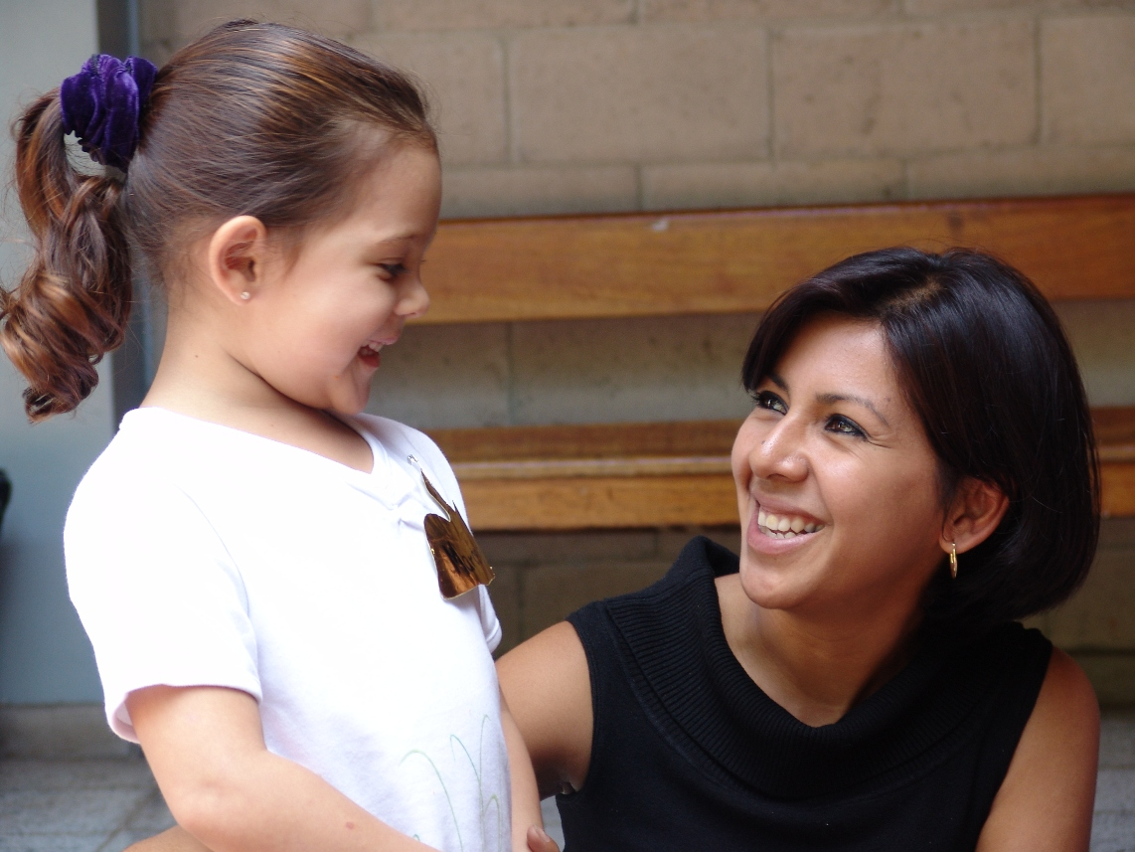

Figure 1.6 A nurturing and emotionally warm tone in your approach to the children in your care, you provide a fertile foundation for their sense of security and self-acceptance.

Beware of the vulnerable child

Think of the child as a vulnerable plant that will bend and wilt if it hears unkind words. Try to speak kindly at all times. If you must raise your voice, do it only occasionally – think how much you dislike it when you have shouted at in the past. Show warmth in the way you speak, use a bit of humour to show you are understanding, and avoid using negative terms such as “Don’t hesitate! Don’t be stupid! Can’t you understand?” or labels and judgements like “You’re so clumsy!” Model tolerance, patience and kindness in all your behaviours, and the children will learn to communicate in the same way.

Communication to promote development

Good communication is more effective if you address the child by his name. This gets his attention and makes him feel valued. Also aim to remember little things he has done well before, and bring these up as reminders to encourage him when he needs it. For example “Sipho, I see you’re trying that new puzzle – I remember you did the other one all by yourself last week. Well done for trying this more difficult one.”

Attend and listen, be emotionally available

Begin by focusing on the child, making an inner decision to listen with your full attention, stop what you are doing and tune in for the emotional message the child may be giving. Acknowledge the child’s feelings. Do not immediately become solution-focused; first be listening-focused. Respect and allow the feelings, by giving the child the opportunity to cry, express anger or whatever he might need to say. This is being empathic.

Encourage the child to trust his feelings. Only after this full expression of feelings has taken place, should you support the child to problem-solve towards a solution that works for him. It is not your role to create solutions. Your listening increases the child’s sense of his worth, and your validation of his feelings allows him to move on to the next step, which is problem-solving in his own way for his preferred outcome.

Manage conflict firmly and reasonably

Try to be accepting of storms and tantrums and use the opportunity to acknowledge feelings first and restore boundaries for behaviour second. Try to stay friendly and understanding. Accept children’s questions about the boundaries or rules, and be firm but reasonable. The simple act of your answering the question tells the child that he matters. When you must discipline or set firm limits, it must be for a practical reason that the child can understand, not just “Because I say so”. Provide clear boundaries, guidance, love and positive discipline, and conflict will be minimised. Such clear boundaries teach children to care about themselves and others.


Praise something specific

Stay focused on giving positive feedback and simply drop the negative from your vocabulary. Look at specific instances and give praise immediately where appropriate. Don’t just say “That’s good” or “You shared nicely today”. Instead notice what the child is contributing to his work or the social situation, and praise a feature of his effort, for example “I noticed how you waited quietly for your turn. You were very patient.” or “I see you’ve managed to fit all the blocks back into the box without a single one missing – well done for being so careful”. However, even a general “Well done!’ is better than no praise at all.

Avoid creating expectations that the child cannot meet, when you say things like “You’re the star tidier in our group” or “Let’s ask our clever one for news about the weather today”. These grand labels put pressure on the child and he may not always want to be the one responsible for tidying up or answering the weather questions. Also avoid general commands to “Be good”; make your expectations specific and manageable on a once-off basis. A helpful way to praise the child is to be specific about the activity, for example “I hope you can help me mix the paint today Joseph, I need a steady hand.”

Steering the process: from feelings to fixing up

When children do misbehave, do not pretend to ignore the behaviour, simply acknowledge the feeling that may be expressed (“It sounds as if you’re really very angry about Ray spilling paint on your shoe”) and then address the behaviour with encouragement to do something positive, for example, “What could you ask Ray to do to make it better?” or remind about the limits, for example, “You seem really angry with Ray… but we have a rule of no hitting. Instead of hitting you can tell him how you feel” or “…and now see if Ray will help to clean it up” and “….and now it would help the two of you to be friends again, if you could say sorry to Ray for hitting him”.

Always take the time to mend a quarrel, especially if the children are about to go home. It is helpful to sit down with the children involved and encourage them to work things out, possibly (not always) reaching a point where they can forgive each other. Again, show empathy for the feelings, then remind them about the limits for behaviour.

Show some physical affection

Show your warm feelings to the children with hugs, holding their hands, putting a hand on their shoulders, saying you like having them around, showing that you appreciate them. Babies need the comfort of touch and cuddles in order to grow, and everyone needs affection. The human touch is extremely healing and powerful. This affection will keep them supported and motivated and increase their sense of freedom because they will feel secure in your presence.
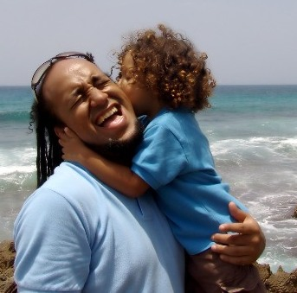

Showing your affection is an important part of nurturing the children at your ECD centre

Stay in touch with the humour of a situation

A little bit of sympathetic silliness can make a child feel understood and comforted. It is also a light-hearted way to talk about behaviour, for example you could say “Sasha, we’re all going to scoot and slip like bunnies on banana skins with these puzzle pieces on the floor, can you tidy them away?” This encourages the child to do the chore of tidying up. Do not use sarcasm, as it is hurtful.

Be honest, and be willing to apologise
Stay honest with the children while filtering out information or emotions that are not appropriate to share. If you have made a mistake, admitting it and apologising is the best thing to do. Practise apologising for your mistakes with adults, as it is a valuable habit that builds sound relationships. It is easy to apologise to a child because children rarely stay angry or judgemental if one has apologised. This also models the behaviour for the children, and it is a valuable social skill for them to learn.

Do not embarrass or talk down to a child

Consider how you would feel if you were in the child’s position. Stay sensitive to any possible embarrassment the child might experience in a situation, and support the child to keep his self-respect. If you must reprimand a child, do it in a way that invites the child to do better (or try harder) next time, being specific about behaviour rather than judgemental. Avoid pointing out the mistake or the inadequacy of the child’s performance in an overly obvious manner.

Contain the anxiety of younger children

Younger children take time to recover from an upset. You can help them re-establish their sense of security by making comments after an upset, to restore harmony, by saying things such as “We’ve finished arguing now and Mimi’s mom is going to mend the torn teddy at home tonight. It will be fine again”. This explanation gives the message that everything is alright again. Babies and toddlers may need some physical reassurance like a hug or a cuddle to calm them down.

Be willing to share a little of your own world

Sharing your own feelings or experience a little opens up possibilities for the child to respond and trust that his feelings and experiences will be listened to. It creates a climate of openness. The emphasis is on ‘a little’ as it is the child who is the focus here, not you as the facilitator. Show empathy with a little story from your own past, for example, “When I was four I also wet my pants at playgroup one day, and I sat on the swing all day because I felt so bad and I didn’t want anyone to know. Accidents happen to lots of people.”

However, sharing personal details of why this happened to you is inappropriate. Occasionally you may find a child who is used to having to act as a responsible parent towards the adult (parent) who is needy and dependent (because of illness, or drug or alcohol addiction). In such a case the co-dependent child is trying to maintain order and control his own anxiety by taking on the adult role. Children who have parents ill with AIDS may be in this position, and have a great need just to be children and to know that an adult is in charge. Do not burden any child with your own anxieties or unfinished business.

Give guidance on social skills

Children usually get coached on social skills at home but whatever they have already been taught, should be reinforced by your support and repetition. Focus on basic good manners like saying “Please” and “Thank you” and making eye contact when they speak to someone. Children will feel more confident if they know they are doing the right thing. Spell out what is inappropriate behaviour and what is appropriate in a certain situation. For example “It’s good manners to not talk while the puppet show is on. Then everyone can hear what the puppets are saying. But of course you can laugh when it’s funny, and the puppets will love it if you clap for them when it’s finished”.

Your own self esteem plays a role

To summarise the guidelines, it is always better to remain calm even when the children are testing the limits of your patience. Any negative outburst of feelings from you, or words said in haste, may hurt the child’s self-esteem and weaken your own effectiveness as a facilitator. If you do have a blow-up, it is important to apologise and make amends.
Example of dealing with your own blow-up
Palesa shouted when she found that four of the children had not tidied up but had scribbled on the blocks with crayons from the cupboard, while she was supervising other children tidying away the scooters outside.
Palesa had this blow-up because she was feeling very frustrated and also worried, as her adult son had been missing for two days. Her shouting gave the children a big fright and she also called them ‘stupid’. Two of the children cried and hid their faces in the beanbags and the other two looked shocked and sulky. She immediately apologised for the shouting, said that nobody was stupid but it was a stupid mistake to shout instead of asking them nicely to clean up the mess. She said she was upset about something else and asked them to be kind and forgive her, and to help to sort out the problem. She asked them to help wash the crayon off the blocks later that day.

Adult-directed and child-initiated learning

Looking out for cues

While you are present with the children in any situation or during any part of your working day, they will be presenting you with cues for your attention. The word ‘cue’ comes from the theatre, and it means the signal that an actor gives to another actor that it is the right moment to say something (or do something). For example, when we meet each other we say “How are you?” and the other person knows that that is their cue to say “I am well, thank you, and how are you?” Sometimes we are in a hurry and we just say “Fine, have you seen my white dog? It ran away”. In other words, we do not respond as the other person expects us to; instead we respond to their cue with our own ideas and needs, and perhaps we forget to ask them how they are. In the ECD context the children’s cues are not so easy to recognise: they may be verbal, nonverbal or purely behavioural, for example a glum and tired face on a child is a good cue to ask “You look sleepy, Ben, did you go to bed late or did something wake you up in the night?” The cue is the signal to adapt your facilitation to meet the expressed need.

Cues can be seen on different levels:
- in the child (for example, something the child says or does)
- in the environment (for example, a very hot day is a cue to shorten the outdoor play time and find a cool place to have a relaxing game, or children may be bored with the activities and not engaging with them, which is a cue to find new resources or rotate them)
- in yourself as facilitator (for example, if you are exhausted from helping your own ill child through the night, adapt your planned programme with alternative activities that will be less demanding on your energies for the morning)
The context within which we use cues to facilitate for holistic development is called the learning context. So as facilitators we need to recognise signals that the children send out when they are struggling to learn something or are open to learning something specific

DEFINITION
Cue: may be words or behaviour, given as a signal of a need. The signal demands a response.
In the ECD setting, the cue comes from the child, and it is your responsibility as the facilitator to respond to the cue with the support the child needs.

Cues are different from clues because cues ask for an active response, while clues are simply bits of information that can be used or not used.

Example of a cue
An example of a cue:

Kuhle: (Looking inside her bag on the peg at home time) Oh no, oh no, oh no!
Facilitator: What’s the matter Kuhle; do you need some help with something?
Kuhle: My mom will be very angry because I forgot to eat my banana. I just found it in my bag. We were playing cricket so I didn’t finish my lunch. My mom says I’m not allowed to throw food away.
Facilitator: How would it be if I wrote your mom a note? I can explain that we will keep your fruit here in the kitchen and she need not send another fruit tomorrow. You can have the banana tomorrow. How can you remind yourself to take the fruit out of your bag at snack time every day?
Kuhle: Maybe we could stick the banana up on the wall… no, it will get old and stinky … a banana picture. I can stick a banana picture up on the wall.
Facilitator: Ok, good idea Kuhle! The picture will remind you to take your fruit out of your bag at snack time.

This cue given by Kuhle was a verbal cue with a lot of emotion, and it was given at a time when the facilitator’s attention is usually focused on saying goodbye and handing over children to parents who are collecting them. In spite of this being a bad time to have to give individual attention to one child, the facilitator was supportive. She made a plan to avoid the child becoming more anxious about the consequences of not eating the fruit. More importantly, she also gave Kuhle two learning opportunities: firstly, to problem-solve for herself and second, to take responsibility for managing snack time for herself. These are social and intellectual skills.

The cue and the teachable moment

The cue may relate to specific skills in an activity. A cue is sometimes a signal that the child is ready to be helped with extra input, to gain or consolidate a skill.

This moment when the child gives the cue and is open to learning is called a teachable moment.

DEFINITION
Empathy: understanding another person’s feelings, motives and situation.
Proximal development: is the difference between what a learner can do without help and what he or she can do with help (Wikipedia: 2009). Proximal development is Vygotsky’s concept that the child is on the brink of managing the skill but needs help to do it, as his developmental growth has not yet expanded to that level of understanding and competence.

Cues may also simply be a request for help with a difficult activity.

Cues are usually a signal for help with a learning task but may also be hidden messages requesting emotional attention when the child is needing support and doesn’t know how to ask for help.

Case study: applying skills to respond to a cue
Let’s look at the example of Sam again, this time with the facilitator’s skills and responses identified in brackets:
Sam: (age 3, sitting with two slightly older and developmentally advanced boys and trying to join in their jigsaw puzzle activity, but trying to fit pieces in without checking the picture) “Let me, let me put this piece in! I can do it!” [Sam’s anxiety and struggle with the task gives the facilitator the cue]
Facilitator: Hey Sam, some puzzles are very hard. [Active listening to the emotional message which Sam’s agitation shows. Observation of the social situation with the two older boys, and of Sam’s motive for wanting to participate in the activity with them. Empathy with Sam’s agitation]
Even grownups take weeks to finish some puzzles. [Empathy and making the struggle normal]
But it gets easier if you keep the picture side up, and find a bit with a lot of picture on it. [Teaching a visual recognition skill to increase Sam’s skill]
Like here, here are some with the whole bird – except that the bird’s beak is missing – can you find the place where this bird piece goes, then maybe together the three of you can find the beak bits? [Redirecting the child to a more manageable and smaller component task; empathic restructuring of the group’s activity to make different sub-tasks for different levels of ability]
Sam: Ok, here, I found two more bird pictures.

More about active listening

Focus on the child’s communication (body language, vocalisations or lack of speech, behaviour or the quality of the child’s attention on the task). Also focus on the context of the communication (for example, in the group at circle time or on arrival in the morning – find out if the cue is given in relation to who else is in the social context with the child). Observe the visible and obvious signals and also the underlying emotional message or feeling tone that the child’s behaviour tells you.

As an example, you should question why a child who loves being surrounded by her peers in indoor fantasy games is suddenly choosing to be alone outdoors in the sandpit most of the time.

More about observation

When you observe the child and notice cues, be alert to any message or motive in the behaviour. Ask “What is it about?” and “Why is this happening?”

For example, if Tomasz (3) who is a bright and capable child, suddenly starts swearing and showing intense frustration while using the building blocks, he will need your attention not only for the frustration but also because of the inappropriate swearing. Find out what the frustration is about and try to find out why the swearing has suddenly appeared in his vocabulary (it may be better to ask a parent in this case than to ask the child directly).

Read these instructions before you begin:
1. Take turns with a partner to describe how you spent your last Sunday, while the other person listens. The listening partner should listen actively for emotions, meaning, details that are unclear, or cues that there might be more to an element in the story. The listener should also observe what cues their partner is giving out about his or her experience.
2. Respond to your partner’s description with questions, empathy and sensitive attention to any cues (verbal or nonverbal) they may give out that there is something more to tell. Respect your partner’s privacy when you probe for more information, by asking “Would you like to tell me some more about that?” when you identify a cue that there is more to the story. Your partner can then choose to tell you more or they can say “I don’t really want to go into the details about that.”
3. Discuss with your partner your experience of active listening and observing.
4. Rate each other on the rubric for your active listening and observing.

Facilitator’s response | 1: Not able to meet requirement | 2. A positive attempt but not satisfactory | 3. A good attempt but room for improvement | 4. Excellent understanding and response
Attention to behaviour (shows active listening and observational skills)
Empathic and supportive communication
6. Answer the following questions:
What is the difference between a cue and a clue in a child’s behaviour?
Do you think cues are valuable to the facilitator? Why?
What is the relationship between cues and Vygotsky’s zone of proximal development?
Why is it preferable to respond to a cue from a child as immediately as possible?
Keep your notes for later reference.

Why is holistic facilitation important?
The current education system is focused on developing the child as a whole person, enjoying rights and responsibilities and a place in society. To reach this goal, you need to stay aware of the importance of being focused on the learning process as well as the learning outcome; the process always includes the whole child (thinking, feeling, working, talking, sensing) and the outcome will represent only a small part of what the child experienced in the process.

Think of all the small actions that go into baking a cake; we are not aware of them when we eat a slice of cake, but they are all essential. In this way, attend to the child’s learning and discovery process as he learns skills and creates products (a painting, a puzzle, a game with a friend), and find ways to value and encourage him in everything he does. The child needs to know that whether or not he succeeds at copying a pattern or growing a bean sprout, he is a person with qualities and abilities that are important and deserving of attention.

The history of holistic early childhood education
Planting a children’s garden
Friedrich Fröbel, who lived two hundred years ago, was a charismatic champion of ‘natural education’. He developed a new philosophy “kindergarten” – a combination of the German words for children and garden. His programme integrated gardening, music, dance and storytelling. It also incorporated playful interaction with a series of educational toys. Known as “Fröbel’s gifts” the toys included building blocks, parquetry tiles, origami papers, modelling clay and sewing kits.
Fröbel’s motto, “Kommt, lasst uns unsern Kindern leben” was translated to “Come let us live for the children” and showed Fröbel’s enthusiasm for nurturing the personal experience of each pupil.
From: Studying the Creation of Kindergarten by Bill Lucas on 2005/10/24 http://www.boxesandarrows.com/person/124-billlucas

DEFINITION
Holistic development: the development of all domains of the child’s abilities: physical, intellectual, social and emotional, moral, language and creative abilities.

- How to facilitate for holistic development
As explained in Topic 9 about modelling, your example is vital to guide the developing child. Not only your behaviour but also your attitude should show respect, nurturing and positive attention to the child. You are an important and powerful influence on the child, and you represent a part of the outside world beyond the child’s family.

- Treat each child as special and take the individual learning level into account.
- Use creative ways to address holistic development. Stimulate imagination and excite the child’s intelligence and creative energies with music, drama, storytelling and interaction.
- Provide a variety of resources that children can explore in different ways.
- Allow learning through action, free play, exploration and discovery.
- Teach in a holistic way by using a natural setting and the resources at hand, for example teach about weather during a rain storm, ask children to identify noises, notice the direction of the wind and rain, tell stories and sing songs about the weather, notice the effect on plants in the garden, and go out afterwards to notice the result.

  - Supporting language, literacy and maths in an early childhood education setting

Categories of communication

Young children learn language from the people in their environment. Your role as a model of good communication and clear expression is very important. There are also social rules for communication that the children will absorb from being in your presence in the social setting of the ECD centre. It is vital that you pay attention to your own language use, as it is the source of learning for the children.

Some communication is up to the facilitator’s initiative, and other communication is as a response to the child. A third category is mutual communication.

1. Initiated by facilitator at all times: warmth, encouragement, physical comfort, nonverbal approval and positive attitude, use of leading questions and open-ended questions, encourage conversation with gentle chatting, probing or some limited sharing of self.
2. Responses required from facilitator to child: sensitive responses to verbal and non-verbal cues, to the culture of child, to the behaviour and activity of child, empathy and acceptance of the child’s reality, respectful consideration of child’s point of view, appropriate praise for work well done, appropriate limit-setting or redirection of behaviour that needs improvement.
3. Mutual communication: sharing about self; questioning and responding.

Talking to babies

Babies (1–12 months) need communication to learn how to shape their speech to match the language of the caregiver. They need to hear you speaking to them warmly as a form of social attention. Talking to babies while you care for them, change their nappies, feed them, put them to sleep, or play with them, is also essential for their language development. Your responsiveness to their sounds teaches them that communication works, and encourages their communication skills.

Looking at picture books together is a way of teaching them to recognise things around them, to concentrate, to listen and to talk. Use simple picture books and simple words, to describe what you are doing and to identify the pictures (for example, “Let’s sit here on the red cushion. I’ll hold the book and you sit on my lap. Here is a picture of a cow. See this big cow. The cow goes ‘Moo’.”)

The physical closeness and cuddling that takes place when you hold a baby and look at a book together, is important to create a sense of safety and sharing. It also helps to develop the baby’s positive attitude to books and reading. Babies learn how to hold a book, turn a page, and read from left to right, from this process of being held and read to. This has a long-term effect on their relationship to books, confidence with beginning to read when they are older, and their confidence with language.

QUOTE
“The way we communicate with others and with ourselves ultimately determines the quality of our lives.” – Anthony Robbins

Talking to toddlers and young children

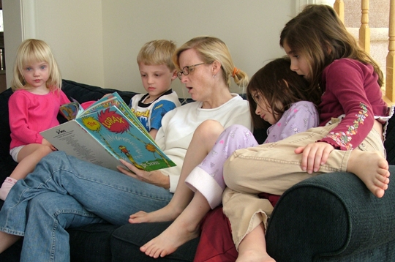
Young children are beginners at expressing their thoughts, feelings, ideas and concerns. This self-expression relies not only on language skills but also on social and emotional development and language therefore also feeds social and emotional development.
By using activities such as storytelling, rhymes and songs in your daily programme, you will stimulate their vocabulary and understanding of language.
Reading with babies, toddlers and young children can help them develop their communication skills

They will gain confidence in expressing themselves, from this language practise. By talking to them, one-on-one and in a group, you encourage them to verbalise their own thoughts, feelings and ideas more fluently. Listening is also an important part of the shared communication, as your listening rewards and reinforces the patterns of the children’s speech and interaction. (Think of the traditional African call-and-answer songs – the isicathamiya – which tell a story.) You should be aware of your talking and listening so that you consciously use them to promote the children’s language development.

DEFINITION
Isicathamiya: is a singing style that originated from Zulu tradition.

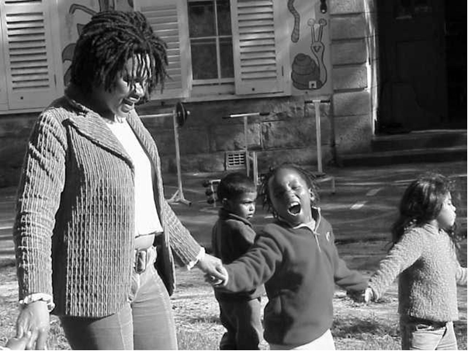

Using questions to grow the conversation

The children’s language skills will grow if they are allowed the time to express what they mean. Your listening encourages this, and is vital to the children’s development of language skills. Use sensible and meaningful questions to respond to what the child has said. This reassures the child that you have indeed been listening. To expand and grow the conversation, use leading questions. This expands the topic and builds upon what the child is saying. In this way, your communication helps to promote development, provide cognitive stimulation and improve social skills.

DEFINITION
Leading questions: are questions that ask for clarification, or give direction and guidance.

Examples of leading questions are: “What games should we play on our picnic day outing?” or “What happens to the playdough if we don’t put it back in its box?” Questions like these stimulate imagination and thinking, which promotes language and communication skills. Another kind of question which helps keep the conversation going, and encourages participation, is the open-ended question.
DEFINITION
Open-ended questions: invite further conversation because they have no specific right answer.

Examples of open-ended questions are: “What news would you like to share about your weekend?” or “How do you think the fox can get across the river?” This type of question allows the children to reach their own conclusions and not worry about whether the answer is right or wrong. Open-ended questions keep the atmosphere positive as there is no way to give a wrong answer. Children grow in confidence, imagination and language ability, by making conversation as they answer.

Chatting is good for development
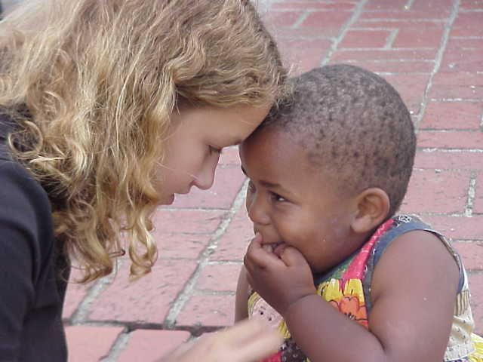
Language development, like other aspects of development, benefits from an allowing attitude from the facilitator. Allow any and every opportunity to be one where talking is allowed. Set the tone with your own chattiness, which shows that talking is welcome.

Babies benefit enormously from the attention of a chatty adult, as their social and language skills are stimulated, even though they may not yet be able to answer. Toddlers and young children will chat to you when you ask how things are going, at any point of your day with them. Show interest in their pet, their family, their special interests or hobbies (for example Cayley is interested in horses and Nthuseng likes dancing and singing with her older sister).

The moments in the programme when you have time to talk, could be during snack time, when they arrive at the ECD centre, during toilet and hand washing time, or when they are packing up to go home. Use these opportunities to show a lighthearted and easy interest in them. Avoid probing or curious questioning, allow the child to say as much as he wants, don’t press for information or the conversation will become stiff. Aim to have a relaxed short chat, and bend down to make eye contact on the child’s level so that your respect for him and interest in him is clear.

What should we chat about with children?

Any interesting experience will provide a topic for conversation. Children also prefer to talk during an outing or activity, so use this opportunity as it will be more meaningful and lively. This will also reinforce any learning that is taking place during the activity.

Also encourage the children to talk to each other. This opportunity frequently arises during arguments, but do encourage it at other times, too. Promote the conversation by suggesting “I’ve heard that you’ve got a story to tell Monelisi – why don’t you tell him about it?” or “Stephen has a new puppy. Ask him how he chose it!”

Using circle time to build communication skills

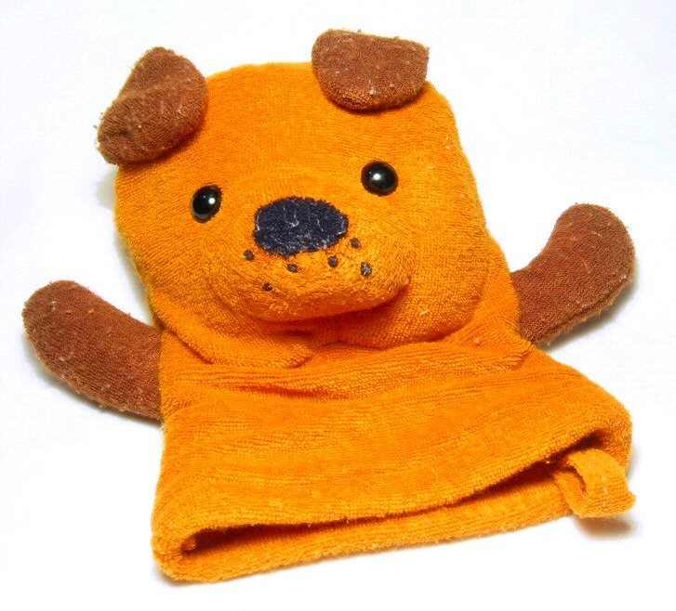
Circle time can be used to improve the children’s communication skills. Singing a song, telling a story or using finger puppets to act out a conversation, are ways to build language practice into the day. Use group time to have a general discussion on topics that are popular, for example plans for a religious festival, or someone’s new baby sibling or puppy. Try using ‘what if’ questions to start an imaginative conversation. Talking in groups can also be focused on counting, ordering or grouping. The group is a flexible context for any purpose, and language skills are built by all of these suggested purposes.
Every activity includes communication

The children communicate all the time, in formal activities or in play. Respond to the child’s expressed feeling as well as to the obvious content of the communication.

In each activity, the children may need to talk and work with a partner, or listen to others in a group and then add their own contribution to a discussion. These opportunities stretch their understanding and get them to develop an integrated set of communication skills (listening, thinking, responding to the social cues, saying their say).

Using books and stories

A book is a resource not just for its story but for the questions you can ask about the pictures or events. Pictures evoke feelings and associations (linked ideas) about the children’s own lives. Allow time for children to sit and look carefully at picture books on their own, in the book corner. The stimulation of thinking and feeling which pictures provide, will lead to the development of understanding and feed into language skills.

Use storytelling as well as books to gain access to the children’s concerns, fears and experiences. For example, asking questions such as “How does this boy feel about what his friend did?” or “ Do you think she should go to the party after all? How would you feel if it was you?” This helps to open up opportunities for discussion and the expression of feelings.

Choose books from other cultures and other countries to add to the learning experience and to stimulate the children’s interest. Children love to hear about other children’s lives, so they will easily identify with children in other contexts and be interested in the differences.

Special books to deal with tough issues can be very useful in your ECD centre. These ‘issue-based’ books on emotional issues like death, divorce, anger, separation, fear of the dark, adoption, provide an easy entry to these topics. They can help to start a discussion and give permission to the child to admit to feelings he may not have been able to articulate before.

Value the child

Your study of facilitation for holistic development so far has included these skills:

- communicating sensitively
- having an anti-bias approach
- being positive, warm, supportive and caring

These skills will not only help the child to develop but your caring approach will also be copied by the children, as they mirror your attitude. If you can enjoy your time with the children or find something to enjoy in sharing the daily activities with them, they will feel affirmed by your pleasure in their company.

A caring child (case study)
Once I returned to a school where I used to teach, and I arrived at about 3pm for a meeting. I went straight to the meeting room and started doing a little writing work while I waited for the meeting to start. (When I used to work there, I would arrive at 1:30pm, have lunch and then help out with the after-school programme till 5pm.)
A little 2 ½-year-old girl came by to say hello. I could see that she was making progress as her conversation skills had improved. For example, she used to repeat everything you said to her, such as “Good morning, Erica!” Then she would reply “Good morning, Erica!” On this day when I was sitting in the meeting room, she came in and was quiet for a few minutes, then she patted my shoulder and asked “Ms Goh, you don’t eat lunch today? Are you hungry? You want biscuits?” I was stunned. That feeling was so sweet, as her little act of caring made me feel cherished.
I realised that this little girl is so observant. I remembered how she was the one who used to say “Hello, Ms Goh!” and follow me all the way to the kitchen every afternoon when I ate my lunch. I used to tell her to return to her play and that I would come back to her after my lunch.
Never belittle a 2 ½-year-old child – she may show you that you have much to learn from her: to be observant, to be sensitive and to show that you care.
Adapted from: http:nurtureourchild.com/laughter/the-little-observer
Copyright 2008 Nurture our child with love and patience.

Verbal and non-verbal responding

Your notes from the activity will probably contain some new ideas, but here are a few suggestions to add to your skills:

Ways to say something positive to a negative child:

- Look for small positive actions to reward with a sincere comment of praise
- Say you are glad to see him when he arrives, and give him a smile when you say goodbye

Ways to communicate positively and non-verbally with a negative child:
- Include him as a helper on an important task every day and occasionally on small tasks
- When he starts making a negative comment, touch him on the shoulder, make eye contact and listen. (Follow this with the verbal response of accepting his feelings.)

Ways to verbally reward a child for positive statements:

- Notice and respond to his statements with something like, “That’s a kind thing to say, Sam, that’s a good way to be friends with Tienie.”
- Amplify what he has said (make its effect bigger) by echoing his statement and spelling out the good effect he may be having on others, for example:
- Sam: I was so busy with that pedal car! I pushed Tienie all around the garden.
Facilitator: You were a busy boy! Did you really push that pedal car all the way around the garden? You gave Tienie a good ride.
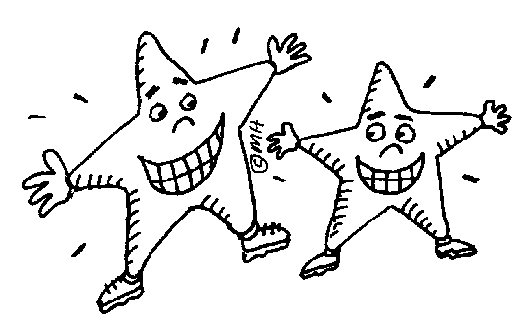
Ways to reward a child non-verbally for his positive statements:
- Smiling, making eye contact, nodding in agreement to his remarks
- Giving him a hug or a pat on the back to show you are sharing his positive feeling.

Facilitating for safety

To ensure that children grow and develop as they should, the playgroup should provide a safe and contained space for them. The age range in the playgroup may vary from babies as young as three months who need hands-on attention and high standards of hygiene, to toddlers who are constantly exploring; and young children are also intent on learning and trying out new skills that may lead them into dangers you cannot imagine. Not only physical safety, but also emotional safety is the right of every child.

Making the play space safe

You are under a legal obligation to ensure that your ECD centre is safe for the children in your care. This safety extends from the smallest part of an activity on the shelf, to the outdoor limits of the play area, the boundary fences, the awareness of the staff and the maintenance of the whole venue to high standards.

A safe environment for babies

Babies’ needs for disinfected bottles, nappy changes and frequent feeding, make strict hygiene essential. There should be sterile nappy buckets with tight lids, separate storage spaces for bottles and food, efficient disposal of waste (disposable nappies and wipes) as well as regular washing of the changing area with disinfectant.

Equipment should be regularly disinfected, baby toys washed and disinfected, and food storage facilities should be adequate. Every baby and child at the ECD centre should have a new facecloth every term and a peg for hanging a bag with a change of clothing. Babies’ hands should be washed before they eat (if they are eating solids) and their hands and faces washed again afterwards. You need to be alert and very careful to protect the health of the babies in your care.

Babies also need a high level of safety in their play and sleep area. Cots and mattresses should be clean (a weekly wash of laundry is essential, and equipment should be wiped down with disinfectant once a week). The safety requirements for toys and resources for babies are the same as those for the whole playgroup.

Checking toys and resources

- Check that toys and surfaces are not painted with toxic paint.
- Toys should have no sharp edges, small parts or sharp points.
- Toys with moving parts should not be able to shoot or eject parts that will injure other children.
- Remove small objects that could be swallowed when your attention is distracted.
- Check toys, tables, and equipment for sharp edges.
- Make sure wooden surfaces have no splinters – sand them with a piece of sandpaper immediately if you find splinters.
- Make resources for very young children with extra care.
- Check that the toy is appropriate for the child’s age and skill level. Demonstrate it, watch the child using the toy, and ensure it is safely put away.
- Learning resources that are safe for older children can be hazardous to little ones.
- Store toys on sturdy open shelves where children can easily reach them and put them away. Label the shelf with a picture to indicate what is stored there. Ensure shelves are strong and will not topple over if a child climbs up onto them.
- Wash and repair toys regularly.
- Keep in mind that toddlers trip and fall easily, and that with babies 'everything goes into the mouth'. Keep track of smaller items and be sure to clear them away after use.
Homemade resources

Homemade play resources can meet the children’s needs very well and can be very economical to make. When making a resource for a toddler or infant, make sure that:

- It is too large to be swallowed;
- It does not have detachable pieces that can lodge in the windpipe, ears, or nostrils (for example pellets from a leaking bean bag, or stuffed doll);
- It will not break easily, leaving jagged edges (i.e. no brittle plastic or glass);
- It has no sharp edges or points (avoid using wire inside a stuffed item);
- It won’t pinch fingers or catch hair;
- It has not been put together with easily exposed pins, wires, staples, or nails;
- It is painted with non-toxic paint, or varnished or laminated.

Guidelines for safe play
- Always stay close by and see what children are doing when they are playing, inside or outside. Learn to see where accidents may happen, and act to prevent them.
- If you are painting toys, toy boxes or furniture, use non-toxic paint or cover the paint with varnish.
- Have rules about putting toys and equipment away at the end of play, to avoid accidents and keep the equipment in good condition.

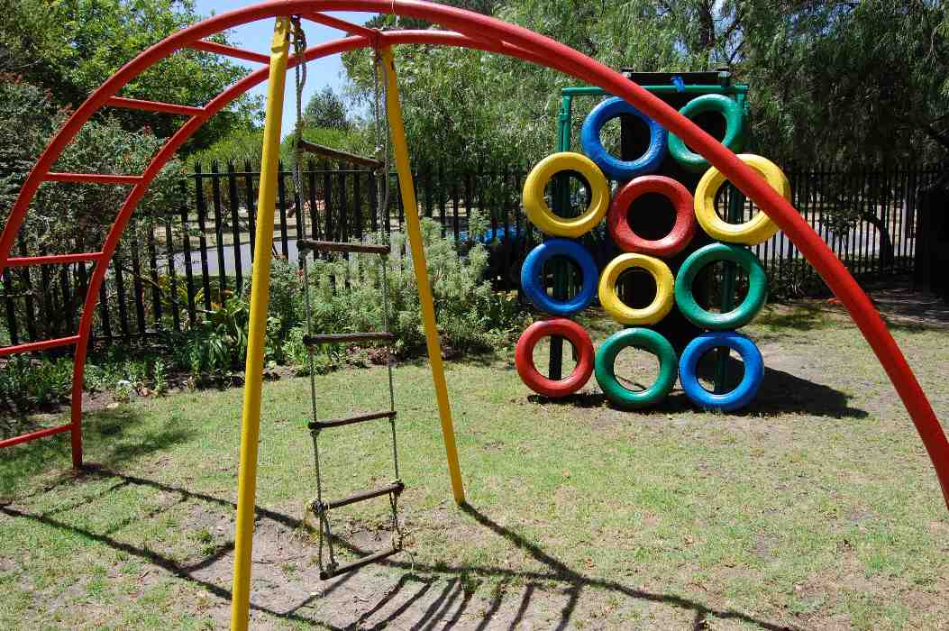
Safety outdoors

Note these safety features that are essential for the outdoor play area:
- A high safety fence
- Child-proof gates
- Space for movement between pieces of equipment
- Equipment suits developmental needs, for example not too high off the ground for three-year-olds
- Soft surface like lawn or bark chips, and some paved areas
- Proper drainage so that puddles don’t build up
- Concrete anchors for large pieces of equipment
- Tall equipment a distance of three metres (minimum) from the fence
- Use shaded areas for any metal equipment
- Oil swings, check connections, oil wooden equipment
- Regularly replace sand in sandpit

Every day rules for safety

Every day is a day to check for hazards indoors and outdoors. Accidents happen very easily, and to be safe, follow this checklist daily. It adds to your workload but is essential to the safety of every child:
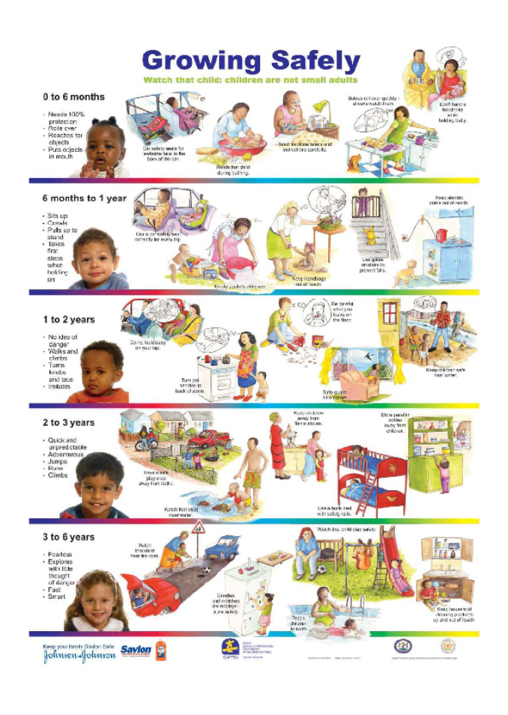

DEFINITION
Life skills: the social skills that humans use to manage their own lives and their relationships with others.

Your important role as the facilitator makes you a powerful person in the child’s life. Your responsibility is to get involved in encouraging and promoting the child’s development. The child learns from you not only because of your action and teaching, but also because of your importance as a role model. This also increases the child’s motivation to learn.

How does modelling take place?

Firstly, the child is paying attention to the facilitator because he regards the facilitator as a warm or powerful person.

Second, the child’s memory, mental images, and imagined rehearsal of what the facilitator is doing, serves as a saved resource to draw on later.

Third, the child begins to copy the image or behaviour. The child may also observe himself acting out the copy of the behaviour and may refine it and change it until it matches his inner mental image.

The motivation for this process comes from any good reason to imitate the behaviour:
- The behaviour may be rewarding in itself, or
- It may lead to some imagined reward, or
- The motivation may simply be that the child now feels he is like the important and powerful role model.

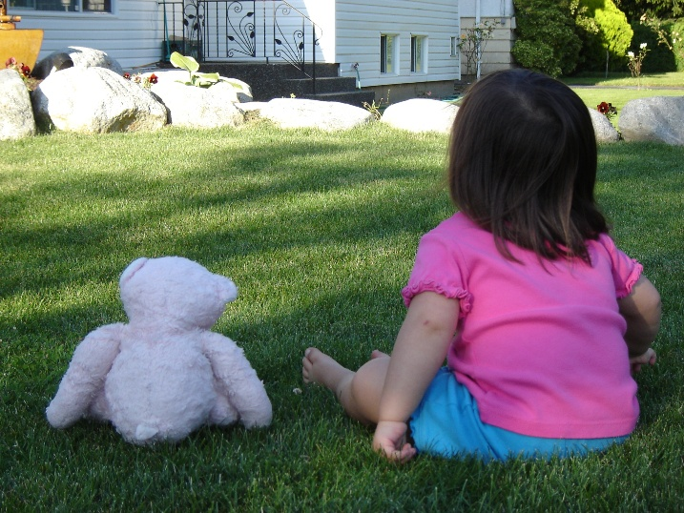
Modelling is when the child or observer identifies with a role-model and unconsciously copies her or shapes his/her own behaviour to fit that of the model

You can’t always choose which behaviours you model

The quality of your attention, your attitude and your social skills are being communicated to the children all the time. Your positive and flexible approach gives the children a sense of security and says, “I am in a good relationship with the world around me.” This is the best message you can give the children through your behaviour, but if your own attitude is far from that, be aware that whatever your attitude is, it is being communicated to the children at every moment.

The core learning behaviours

Attending and problem solving are core behaviours in all learning, and by modelling them, you set a good example for the children to follow, and to succeed at their own learning. Your focus of attention when helping a child with a craft activity or with tidying up, demonstrates how to get the job done, and how to solve problems through effort and focus.

Your own life skills

You are an example for the child to follow, and the other valuable skills that you model for the children can broadly be called ‘life skills’.

To the child, the caregiver represents the outside world. Your own life skills of cooperation and competition, conflict solving, building and keeping friendships, managing relationships with sincerity, sharing and loyalty are shown to the children as you interact with them every day.

Your life skills are a foundation for the children

The diagram below shows how your own values and habits form a foundation that influence the children. For this reason, it is important that you have a healthy relationship with yourself.

Children do what they see

The way you manage your relationships teaches the children how to manage theirs. Children do what they see, even when they see poor examples; they learn social skills almost by breathing! Your own mistake in communicating, or an unguarded moment of anger, may be seen and absorbed by the child. The child’s parents are the most powerful models but the fact that you are in daily contact with the child, means that you may be the second most powerful influence. Your values will colour and affect the child’s own relationships.

Modelling for the developmental level

Always bear in mind that the children can only make sense of your behaviour and values at their current level of development and intellectual understanding. Have realistic expectations and trust that the children will absorb and use as much as they can at any point.

Modelling inclusivity

Your own acceptance of a variety of cultures and of disability depends on how comfortably familiar you are with those differences from your own culture and life. Refer back to Topic 3, and your journal notes on what you learnt about different cultures and abilities. Use those notes to chat to the children often (at least three times a week in circle time) about what you know about other cultures and disabilities.

Use the analogy of all the flowers in a garden – they are different colours, shapes and sizes, and that’s how people are too. Make a photographic collage of children (and friendly-looking adults) of other cultures and those with disabilities, and chat to the children about the new faces you keep adding to the collage. Teach the older children the song We are the world and encourage the idea that all the children all over the world are like one big family. The children will grow up in a much more integrated world than you are currently experiencing, and they need your foundation of acceptance to manage that gracefully.

- Collect pictures, artifacts and music about different cultures and kinds of disability.
- Make a rule that discrimination against anyone on the basis of race, culture or disability will not be allowed, and anyone who does so will have to spend 20 minutes weeding the garden (or similar ‘community service’).
- Show a good example of unbiased attitude and behaviour to anyone you meet in the ECD environment, or on outings with the children, or in story books or resources. Have anti-bias resources in the playroom (consult your list of issue-based books) and include a variety of cultural festivals and foods in your programme.
- Take pride in the multicultural openness of your ECD centre. Show respect and compassion, and the children will behave in a respectful way too.

First teach social skills
The children in your ECD centre will come from different backgrounds with different levels of parental expectation of good behaviour. It is helpful to set up basic rules for behaviour and good manners, which all the children must adhere to. This creates clear limits for everyone. First you should research what good manners are and how useful or constructive they may be to social relationships. The changes in society and the multicultural mix have blurred the rules for good manners – so it is necessary to clarify for yourself what you expect from the children as ‘good manners’.

Teaching good manners in the ECD setting

Children who have good manners will enjoy better social relationships, and make friends more easily. They should also understand that it is important to consider others’ feelings and needs, by being kind, thoughtful and respectful. Explain to the children that having good manners helps them to make and keep good friends. Children without good manners may find themselves lonely, or labelled as selfish by others.

These behaviours are easy to teach to the children. You should already be modelling them for the children – check your own manners before you attempt to teach them.

When you teach children good manners, expect that their impulsivity may sometimes overcome their manners, and consider the developmental age of the child. Manners can be taught from an early age but as children grow older, their manners will be more reliable.

Which rules work for your group?

Do this short activity with a partner to clarify your thinking about what kind of rules should be used in at your ECD centre.

Discuss the rule poster with the children, ask them for examples of each rule, add examples you think are relevant, for example ‘no hitting, as this does not respect the other person’.
Guidelines for constructive behaviour management

- Show by doing: The children are learning social skills from your example. They will do as you do, so be sure to use respectful language, say “Thank you” or “Excuse me”, as you would in any social setting. These good manners then become part of the children’s own habits.
- Encourage open-ended play, to provide practise and insight into the value of cooperation and consideration for others. Play is a practise arena for the children to try out new skills.
- Encourage special friendships to provide daily practise in social skills. Younger children who are not yet able to play cooperatively will benefit from a friendship and begin to learn to cooperate. Promote friendships amongst the children, especially stable or special friendships.
Encourage empathy and compassion, as young children are initially egocentric and may try to be thoughtful, but tend to fall back into self-centredness. The children’s sensitivity will grow as they develop, but they need to be reminded to think about how others feel.

Below is an example of the difficulty of sharing.

Example of sharing problems
1. Candy (3) is visiting Sarah (2 ½) at the play house in the house corner. She brings with her a blue handbag from the dressing-up box, which she carries over her shoulder. She picks up three Lego men that Sarah has put on display like ornaments, and puts them in the bag. Sarah says ’No!’ and tries to take the Lego men out of the bag. They struggle and begin to scream. Sarah pulls Candy’s hair. (Aggression)
2. Thomas, aged three, has a pile of Lego in front of him but is using all the Lego men for his building. Tina asks him for two Lego men for her bus and he simply pushes all the other Lego blocks towards her. She tries to snatch the two red Lego men from Thomas’s building, and Thomas lets go of it and starts to cry. (Flight or withdrawal)
3. Dikeledi, age four, is playing with the red pedal car. She gets off to go to the toilet and comes running back to find that Sam is sitting in the seat. She shouts, “Mrs Kay, Sam stole my turn in the car. He’s rude!” (Tale-telling).

These examples are typical of struggles with favourite toys and show how the children quickly fall into screaming, crying, snatching or hurting when their possession of a precious object is challenged. The children resort to aggression flight or withdrawal (as shown in the crying) and telling tales. How do we teach them to share?

Sharing begins to improve gradually as children begin to understand that the toys are not part of themselves but separate objects. As a result of their immature sense of self, toddlers are not developmentally ready to share. As they grow from toddlers into pre-schoolers, they begin to understand what belongs to their own bodies. Their understanding of their own body boundaries improves, so they are better able to let go. From age three to age five, they slowly develop a stronger sense of self and are not so threatened by toys being removed or going to someone else for a turn.

Making it easier for children to share
Support and encourage sharing by keeping duplicates of toys and also a wide variety of toys and resources to choose from. Encourage turn taking so that children gradually learn to share as they get older, set time limits for play with popular toys, and teach the social to-and-fro of asking to share a toy.

Example of talking through a sharing situation
If Riyaad has snatched a toy that Sam was using, you can say, “Sam hasn't finished playing with that toy yet.” Explain to Riyaad that he needs to give the toy back to Sam. Then, if necessary, you can say, “You need to give it back. Can you do it by yourself or do I need to help you?” If Riyaad doesn't return it, you can gently return it. Give each child the words to say, so that over time they will learn how to talk about this together. Sam needs to know how to say, “I'm using it”, and Riyaad needs to know how to ask for a turn: “May I have a turn when you're finished?”

How to resolve conflict between children
Children need to learn problem-solving skills, to cooperate, compromise, and listen to each other.

A step-by-step approach to teaching conflict resolution to children

Ask what happened

The first step is to ask calmly ‘what happened’ and hear the story from both sides. The facilitator should acknowledge the facts and the feelings of each child. In this way each child hears the feelings of the other, and begins to see the situation from the other’s point of view. Some children are unaware of how their behaviour affects others, and they must have this shown to them.

Define the goal

Define the problem in terms of what both children want to happen, and the goals they both want, for example, “It sounds like Sam wants to build a city with roads for cars and there is no space left for Mimi to have visitors come to her play house.” This acknowledges both their needs and the children understand that both their needs are important.

Brainstorm for options

Get the children to brainstorm about possible solutions. Do not add your own suggestions, just record the different ideas and keep asking “What else?” until the children run out of ideas. You could ask the child how someone else might solve the problem, if he seems to have no ideas.

Evaluate the different consequences

Consider each solution and its consequences in turn. Ask the children how they feel about the different solutions, for example “What would happen if we did it this way? How would you feel about that?” Encourage the children to evaluate the ideas.

Decide on the best solution

Restate the problem, summarise the ideas and let the children identify the most promising solution. If their chosen solution seems unlikely to work, be ready to start the process again. Make a plan for implementing a solution.

This process is slow but teaches children the valuable skill of thinking up possible solutions and considering others in finding a solution to fit everyone’s needs.

The core skills for resolving conflict

This method relies on core skills which you should slowly begin to teach the children:

- Listening and allowing: Allow the person to express the problem, tell them you have heard and understood, accept that that is how they feel, discuss a possible meeting point where the two points of view connect.
- Making amends: find out what the other person wants to make things better. It may not be an apology; it could be some practical form of action. This may involve compromise or sacrificing something for the other person.
- Apologising should not be emphasised too much but it does have a place. The child should be encouraged to say they are sorry and that they care about the other person. It may not be essential to admit that they are wrong, but the child should show that it matters that the other person was hurt or offended.
- It may be necessary to ask for intervention by a third party who is not involved in the conflict. The child may take this initiative to sort out a problem. The third party is not meant to take sides with one child but to assist both children.

Alternatives to physical punishment

The law in South Africa says that it is illegal to punish a child with corporal punishment in the school or ECD setting. A more constructive alternative to physical punishment is to withdraw privileges or allow the child to experience the logical consequences of his action. Children learn gradually to control their emotions in socially acceptable ways. We also expect them to gain control of their behaviour and to take responsibility for their feelings and behaviour. Your role is to teach this self-control, in manageable steps. By the age of four or five the child should have moved beyond tantrums and outbursts, and should have better control of his feelings.

Behaviour management at different developmental stages

The techniques used for effective discipline should meet the needs of the different developmental stages. Ann Cawood, an experienced social worker who works with parents and families, recommends these age-appropriate techniques (Cawood, 2007: 88–89):

The baby stage

During the first year of life the baby’s needs begin to become demands, and they can be limited when they become unreasonable. Use a firm tone of voice to begin to set limits at around six months, by labelling the feeling, and continuing to do what you need to do; for example, “I know you want me to pick you up, but you must wait a bit while I tidy all the cushions away.” Use the following techniques:

- Firm no-messages: “No, we don’t touch the flowers in the vase.”
- Distraction with an alternative activity: “Here’s the shape sorter. Let’s see if you can pop them all in the holes.”
- Child-proofing: All dangerous or unsuitable objects for a baby should be moved out of reach or locked away.
- Constant adult supervision and consistent limit-setting.

The toddler stage

- Avoid a battle of wills by avoiding giving absolute orders that the toddler would love to contradict. Decide on suitable boundaries (state the rule) but also give a choice, for example, “You can eat your sandwich when you sit down quietly at the little table” or “You can have a turn in the paddling pool when you’ve tidied the toys away” or “It’s time to put on shoes for going home. Do you want to sit on the beanbag to do that, or do you want to sit here next to Vuyo?”
- Give a timeous warning: Give an announcement of forthcoming tasks, to give the child time to get used to the idea of what has to happen, for example, “It’s nearly snack time. You can go on the slide a few more times and then it will be time to wash hands.”
- Have realistic expectations: the toddler is not deliberately manipulative or antisocial, but simply testing limits and developing a sense of separate identity.
- Contain the feelings and limit the behaviour. Diffuse temper tantrums: Do not reason with a toddler who is in the middle of a tantrum; hold him firmly to ensure he cannot hurt himself, and try to calm him down with soothing words. Also respect the toddler’s limitations and do not add stress to the situation to stretch him beyond his ability to cope with a situation (for example, expecting him to tidy up toys immediately after a nap).
- Use natural consequences. The natural consequences of an action may be a hard lesson: if the child hits his friend, the friend may hit back; if he forgets his snack at home, he may have no snack; if he leaves his book outside, it may be ruined by the rain. You should use your discretion in managing this experience, and always discuss what happened and why. This creates a powerful conscious learning experience.

Age three to six

- Avoid overly high expectations and do not pressure the child to perform.
- Limit demanding or negative behaviour by using I-language: “When you throw your lunch on the floor, I feel very cross because of the mess.” Follow up with logical consequences: “You can help clean up by fetching a cloth from the kitchen, or else you must leave the table and sit alone on the beanbag.”
- Allow time for a security object to be given up gradually.
- Reinforce rules and limits for mealtimes, nap times and toileting.
- Direct towards the consequences: Allow children to take responsibility through their experience of the consequences, for example, if Tienie leaves the scooter outside in the rain, it gets wet and he must dry it down with a cloth before putting it away. If you do the drying yourself, you are depriving Tienie of experiencing the consequences and of changing his behaviour. Encourage the children to make amends after an argument with a friend, fix what is broken, and clean up after an accident with the paint. In this way they learn to understand and take care in their relationship with the world.
- Encourage problem solving: This is also a core skill to empower the children to manage situations so that they experience self-reliance on their own resources. Decision-making skills are a by-product of problem solving.
- You can gently guide the child from a negative to a positive behaviour choice by redirecting the child. For example, if two children are fighting over a toy tip-up truck, it would help defuse the conflict if you could provide a second tip-up truck. If a child is jumping up and down on a chair, you could say: The chair is not for jumping on, you may jump on the floor.” Or, you could shift the child’s attention to a new activity, reducing the focus on the conflict situation. Children will learn to do this for themselves if you model it for long enough.
- Allow children to make their own choices. When you do this, you encourage them to be independent and to think for themselves. If you provide opportunities for making choices, the children will get used to this way of dealing with a problem situation and learn to assert their individuality and take responsibility through the choices they make. For example, you can say, “Oh dear, your painting is dripping on the floor. You could clean up with this wet cloth or with the squeegee mop” or “I see your knee is hurt, Dineo, it must be very sore. You can sit here on the beanbag while I clean it, and you can hold Tienie’s hand for comfort, or we can go to the bathroom, but screaming and running with a bleeding knee is not allowed.”
- Making choices builds self-esteem. Just be sure that your limits for a range of choices is well understood and that you are ready to be firm about those limits, for example, “You can have the last piece of birthday cake if you will take the tray to the kitchen and wash it afterwards.” You should state what decisions are not negotiable, for example, “Everyone can stay and play with water for five more minutes if they want to, but then everyone has to wash their feet under the tap before they come inside for story time. No sandy feet will be allowed inside.” Developing the freedom to choose makes a big difference to the child’s self-esteem, provides a sense of control and trust in himself, and makes him more co-operative as a result.

Age six and up

- Use all the techniques described above.
- Praise with a personalised description of the behaviour.
- Find things that the child is good at, to develop the child’s self-esteem in order to better manage the behaviour changes that may be needed.
- Validate the child’s feelings; do not dismiss them as silly. (Cawood, 2007: 97–100).

Dealing with parents’ concerns

Parents may be eager to give feedback on their children’s improvements or may be anxious about their development, so they will respond to the programme ( your facilitation) through the perspective of what their child tells or shows them.

The main feedback you need to hear from parents is that the children are enjoying the activities. Parents may be pleased that a child is singing a new song, or has a role in the end-of-year concert. If parents are unhappy about any activities or they report that the child is unhappy, take time to find out exactly what the issue may be.

Educating parents about to the ECD centre’s approach

Introduce yourself and your facilitation approach to the parents before the year begins. Send a brief letter welcoming them and their children to the ECD community and explaining your philosophy in a simple statement. Give a concrete example of how your style works (for example, “I attend to each child’s individual learning needs and encourage participation to the best of the child’s ability. There is no pressure to create any specific product or to compare work with other children. The focus is on the individual child’s development.”) This helps parents recognise that your approach is focused on the process of learning. Invite feedback from parents via the suggestion box, or by contacting you in the afternoon, or attending the feedback session in the regular parents’ meeting.

Making time to deal with parents’ concerns

When you notify parents about any meeting, list a feedback time on the agenda so that parents can come prepared to talk about any issue that concerns them. This may or may not include feedback on your facilitation, but your facilitation will benefit from knowing what it is that parents wish to say. Meet with each set of parents for a few minutes to find out what they need to tell you. Draw up a feedback or suggestion slip for parents to fill in at any time, and have a locked box at the front door of the playgroup, where they can leave these slips.

Responding to parents’ feedback

Parents are not usually aware that facilitation style or competence is an issue. If they do give feedback, it must be met with respect and acceptance, and your response should be polite and accepting. You can offer to think about their feedback and give them a follow-up phone call or brief meeting in the next two weeks once you have reflected on the issue.

Your decision as to how to use the information depends on the nature of that information. Use these general guidelines in responding to parents:

1. The child is your priority, so avoid putting your pride in the way of accepting feedback.
2. Listen and make sure you understand what the issue is for the parents. Reflect back to them what you understand from what they are saying.
3. Keep communication lines open, and keep talking to them about their concerns and their child’s participation, even if there are tensions.
4. Be willing to support the child and his parents to accept the ECD centre, and you as the facilitator.
5. Keep observational records about any parental feedback and note any conclusions in your journal.

Feedback shows your weaknesses – and strengths

Try to be open and accepting of the feedback you receive about your facilitation. Use it constructively to build on your strengths and eliminate weaknesses. Use any of the following devices to analyse the strengths and weaknesses of your facilitation:

(a) Strengths, weaknesses, threats and opportunities (SWOT analysis)

How could Robbie (see the case study about Robbie on page 95) use a SWOT analysis to reflect on his facilitation skills? The sample SWOT grid shows how he would conduct this self-reflective exercise.

Strengths  - I am an enthusiastic facilitator  - I am sensitive to all the learners and I am able to set limits for behaviour  - I invite observation and feedback from others when I have a problem | Weaknesses  - I sometimes weaken my approach by involving myself too much in the family circumstances and unmet needs of the children.
Opportunities  - I could be more focused on my role as facilitator and less on my symbolic role as a male figure for the boys  - I could be firmer with the boys | Threats  - Robbie has a mistaken idea about the experience he can provide for fatherless boys in his playgroup  - Boys who act out are in need of firm limit setting and clear rules for behaviour

Using the SWOT analysis above, Robbie realises that he is a good facilitator on the whole but has a weakness of becoming too involved in the family circumstances of the children, and tries too hard to provide what he thinks is a therapeutic response. What really happens then is that he weakens his facilitator role.
His strength is that he has the willingness to consider feedback and review his own performance in search of a solution to what is not working. He is also able to change his behaviour when necessary.

The weakness identified in the feedback is not a matter of Robbie not knowing what to do, it is a focus that is inappropriate for his facilitator role (he is trying to be warm and accepting of the boys’ needs for a father figure but this warmth is at the cost of his firm management of the group; the boys need this firmness too and that it the limit of Robbie’s role and responsibility to them).

The strengths Robbie already has can easily be applied to his handling of the boys’ behaviour, once Robbie understands the mistake he is making.

The opportunities are the positive changes Robbie is able to make to his facilitation once he understands what is needed. He sets firm limits, remains warm but responds with clear messages about what behaviour is unacceptable in the group. He makes use of the opportunity to simply apply skills he already has.

1.4 Types and features of basic resources and teaching aids, including adapted equipment

Does the resource fit the developmental need?

Does your ECD centre have a good, varied supply of ECD learning resources? There should be materials for every age group that is represented at your ECD centre. This is your resource bank to use when planning your learning activities. It is through play that children learn about the world and people around them, and about themselves. Every play activity encourages the development of skills, whether it is structured with resources, or free play with imagination and home-made objects. It also provides space and time for creativity and imagination to grow. Choose learning resources that your children will enjoy, and that will also encourage their learning. This will make their early years memorable and filled with the joy of learning new things.

The following skills should be stimulated in order for development to take place:
- muscular strength and coordination
- colour and shape recognition
- social skills for group games
- problem-solving skills
- understanding of logical processes
- creative initiative
- cooperation with peers

What would Linda do?

It is easy to make good learning resources from available materials if you have enough patience and can learn basic skills, and are happy to add some creativity of your own. What makes the resource useful is how adaptable it is for different needs and activities, for example, a small box could be a bed for a small doll, or it could be painted and used with other small boxes to build a colourful wall. Try to double up on scarce and popular resources that all the children like (for example, ride-on toys with wheels are very popular and it is hard to have enough for everyone, although the children also learn cooperation through taking turns with scarce resources). Let’s imagine that Linda finds a sponsor who will donate ten new toys a year to her playgroup: how should she choose what to ask for?

How do I choose resources?

You and Linda should use the same basic criteria to choose appropriate learning resources for your ECD playroom. To get the most use from resources, and to ensure they meet the children’s changing needs, you should choose resources that are suitable for use in groups, are safe for the age group that will use them, and that have child appeal (colour, detail, imagination and a sensory quality like texture, movable parts or sound).

Fun ECD learning resources for each age

These resources are flexible and can be used by children in a variety of ways. Your facilitation of the children using them will depend on your knowledge of child development. Always make safety the priority when considering the resources you offer to a child. Let’s consider the kinds of resources suitable for different developmental ages:

Babies 1 month to 12 months

- Soft toys made of a variety of different textured fabric
- Pictures with bright colours and also high levels of contrast (for example, a mobile made of newspaper cuttings and fragments of coloured paper cut from magazines)
- Rattles or mobiles with sound (for example, made from old cutlery on strings, or seashells and pieces of wood)
- Balls of different sizes (make your own with newspapers stuffed into an old pantyhose leg, sewn into a ball shape)

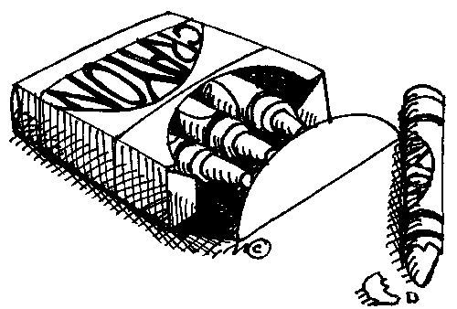
From 6 to 12 months

- A variety of story books to be read aloud
- Music, songs, rhymes on CD
- bricks and building blocks
- thick short crayons
- sets of containers for water play or for putting things into

Toddlers 12 to 30 months

- thick short crayons
- playdough or modelling clay
- construction sets
- one-action learning resources (resources that encourage the child to repeat one particular action, for example a hammer and peg board)
- sandpit and water
- wheeled toys to push and ride on
- simple and small-scale outdoor equipment (logs or tyres to climb over, tunnels to push through, low swings)

Young children 30 months to five years old

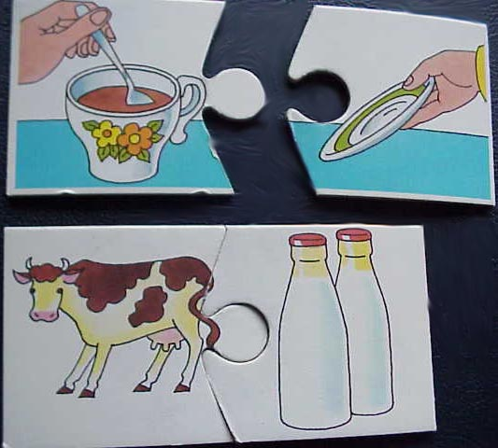
- paint
- crayons
- dressing-up clothes and equipment
- puppets
- picture books
- matching games
- sorting activities
- memory games
- jigsaw puzzles
- sorting games
- jungle gyms, swings, ropes ladders and other outside play equipment, including scooters and bicycles
- toy versions of tools and equipment found at home: pots, spoons, cups, trowels etc.

Children five to seven years old

- board games
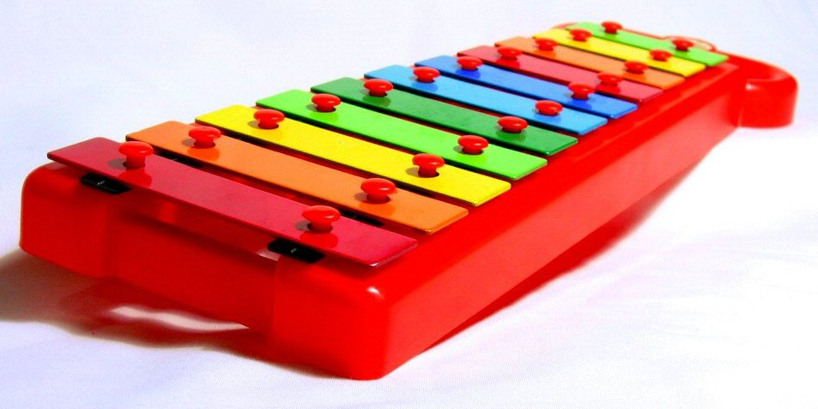
- medium-sized dolls of both sexes that can be dressed in different sets of clothes (preferably not so small as to cause frustration. Barbie and Ken type dolls have very small clothes that may be beyond a five-year olds level of fine co-ordination. They are also not suitable for young children as they depict sexualised adults).
- musical instruments

- craft activities to create something as a gift for parents
- building sets like Lego or Meccano (similar cheaper brands are available).

Adaptation for children with special needs

Many playgroups have children with special needs. If you have enough variety in your collection of resources, you should be able to find an appropriate resource to stimulate the child. Aim to provide something appropriate at all times to keep special needs children on track with their development.

Does the resource create fun?

Fun includes a sense of pleasure or ease (which comes from the familiar or the safe) and something that is unexpected, challenging or funny. To give the children something they can manage well, the activities should match their skill level. It is difficult to provide activities that match the different developmental levels of the children in your class; for example, you may have four six-year olds who are all at different levels of development of fine motor skills. To avoid the children getting bored, slowly make the activities more challenging as the children become more skilled. Do the children seem uninterested in the activities, or confused as to how to do them correctly? Do they quickly finish an activity or give up after a minute? Make a few adjustments to an activity and try it out again, to find a link with the child’s level and interests. In this way you can meet the child’s changing needs for stimulation and challenge over time.

Avoid long and involved activities that make the children become restless or stressed. An activity may be too easy if the children are not engaging with it. Simply move on to the next activity, and aim for lightness and laughs. This may sound hard to get right, but here are a few guidelines:
- Do not have a fixed result in mind but allow the child to decide how to finish or resolve an activity. This makes for a sense of satisfaction as the child creates the result he can manage at his developmental level.
- Get the children to choose the learning activities they want to do (you can set up a small selection for them to choose from).
- Be flexible with time so that children can ask questions, experiment, make choices, try their own creative solutions.
- Keep the activities child-focused. You will know what the children are preoccupied with in a particular week, so link the activity to a story about that subject. For example, tell a story about a child who is growing out of his shoes very fast, and has to go shopping with his mum for new ones but doesn’t like wearing shoes at all; or a child finding it hard to come indoors at the end of a free play session. The older children (age 5 and 6) may be experiencing this. You could also have a game with younger children about how to teach one of the favourite soft toys in the playroom to wash its ears with a facecloth.

Example of a fun game
One activity or game can be a source of all sorts of tasks, challenges and satisfactions. By using a game that children usually enjoy, for example a shopping game, you can introduce a fun element to extend the game and make it special. To play at shopping provides them with opportunities for skills-building like carrying objects, making decisions and choices, recognising and naming familiar products, cooperating with the shopkeeper and taking turns with other shoppers, and asking the shopkeeper politely for something the child likes or wants. Collect empty boxes or containers (like toothpaste boxes, Marmite jars – clean and washed) to make the game more realistic.


Suggest to the children that when they go to the shop, they may ask not just for the ordinary items like peanut butter and toothpaste, but also for one wish. The child may ask for whatever he wants (like a tree house for him to play in with his friends) and then the shopkeeper asks him to pay by saying the magic word. He must then say the magic word (for example, “mixamaxamox”). The shopkeeper must reply “I hear your wish and I wish you well“. (All the other children can say it together with the shopkeeper.)

The way to make activities sufficiently challenging enough is to use the familiar but add something to stretch the child’s abilities a little. Keep the focus positive and happy, and use themes from nature or the community and local setting.

Are the activities developmentally appropriate?

Having fun is the easiest way to learn something. Make sure you provide activities that are creative and exciting, drawing on the ideas, actions, and preoccupations of the age group you are working with. Their developmental age must be the guiding factor in preparing your learning programme and in guiding your own expectations and responses.

Consider how your knowledge about child development can help you facilitate better, by knowing what kind of learning takes place at different ages:

Concrete learning experiences

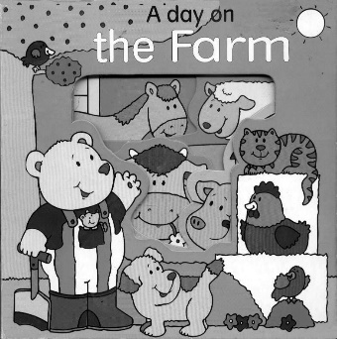
Children from birth to three years of age primarily use their senses to explore concrete objects. During this phase they have to see, hear, touch, taste and smell to learn.

Semi-concrete learning experiences

Children between the ages of three and five years of age are able to relate pictures to the real objects that they explored earlier.

Abstract learning experiences

Children from age 5 can grasp the meaning of symbols and abstract concepts that cannot necessarily be explored by their senses.
(Maree & Ford 1996: 9, 10, 32)
Although these different learning styles are generally true for these age ranges, the learning process is like collecting apples in a basket. Once a child has a skill, he or she can use it during the phases that follow. For example, the 5-year-old child who is capable of abstract learning (for example building with Lego or matching shapes in a complex puzzle) will still enjoy using his sense of touch to explore the texture of new objects (for example, the squishy feel of his baby brother’s dummy).

This knowledge will assist you as the facilitator to create activities that will specifically focus on the child’s developmental stage. For example, include objects of different textures in the baby room.

Make the familiar into something new

Not only new things are valuable to the child. Learning is easier if the child has a sense of something being familiar or vaguely similar to something he or she has seen before. This provides the sense of safety and comfort that makes it possible to tackle a new task. Any new object provides stimulation and new play possibilities.

You can rely on whatever you can find in the natural environment around your ECD centre: little pebbles, seeds, leaves or shells. These could provide materials for a variety of activities. For example: leaves for nature collages, seed pods and shells for sorting. Beans, peas or some herb plants could be germinated using an old ice cream holder and some cotton wool. These can later be transferred into a larger holder and grown on a window ledge until they are ready to transfer to your garden.

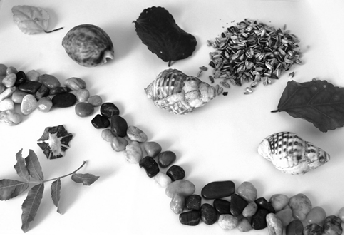

Pebbles, seeds, leaves and shells can be used for creative activities
Anything goes

Learning resources can be improvised or created to fulfil a particular purpose. For example, coloured blocks from the block play area can be used to sort into different coloured boxes to teach colours. The children’s blankets, chairs and tables could be used to build a tent in the classroom where they can play ‘camping’ or ‘picnic’. Children are very creative – allow them to discover new things and new ways to apply old objects. They will probably be able to teach you how to do that – so listen, observe and allow them to improvise and chances are that they will regularly come up with new games to play.

Scrap

Learning resources do not have to be expensive and can be developed from scrap materials. For example, involve the families by requesting them to help you gather empty boxes of breakfast cereal, plastic tomato sauce bottles, empty peanut butter jars, etc. (With these you can create a corner inside or outside that could serve as a make-believe shop. The children can take turns in being the shop owner and the customers.) A big box could be converted into a doll’s house by cutting a door and windows into the sides. Let the children help you to paint the box during a creative art activity.

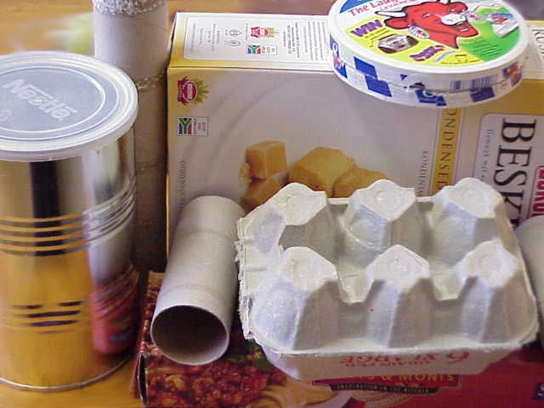

With a little bit of imagination, everyday items around the house can be used as resources for a number of activities

Commercially available resources

The ECD playroom also includes learning resources which are available commercially, for example, jigsaw puzzles, picture books, and board games. Good experiential and role-playing toys are those which are smaller versions of home or office equipment, like cash registers, cameras, old fashioned telephones, and outdoor equipment like wheelbarrows and lawnmowers.
Does the resource link the child to the wider world?


Themes are a way to bring the world outside the ECD centre into the child’s world in a safe and easy way. The child’s world may be quite narrow, focused on home and the ECD centre, with some familiar places like the shops or the park being the limit of his or her knowledge of the world. To give a glimpse of other things the child can get to know, you can use themes, but they should be culturally sensitive and appropriate to your ECD environment.

A theme makes it easy to find concrete, sense-based experiences that are rich in learning opportunities. Keep your approach flexible and adapt themes from year to year. Each group has different needs; you also need to keep the material alive and interesting for your own sake as facilitator. The value of a theme is that it gives the child an opportunity to explore through the senses, to touch, handle, smell, taste and move around the elements in the theme. By exploring, the child can proceed from the familiar to discovering something new.
Make the link between the wider world and the child’s world in the following ways:

- Begin by focusing on the crisis point or growth point in the child’s development. Water play with containers is suitable from a young age (18 months) and remains suitable for children younger than seven, as it provides practise in problem solving to meet the needs of the pre-operational or intuitive reasoning child. This is an example that fits many developmental stages, but there are other stages that need specific activities to promote skills, for example, language development makes a big leap from age two to age three, so language activities are very important at that age.
- Tie the theme to an element from the child’s culture, home language and context.
- Include stories about children of the same age.

- Refer to the known physical world that the child lives in, for example his home neighbourhood and community, the ECD centre neighbourhood, and familiar activities that the child shares with his parents, like walking the dog or visiting granny.
- Use fantasy and magical ideas based on content that is safe and appealing to that age group, for example butterflies that can talk (age 2–4) or ‘the lion family’ for age 5–7.

As each age has specific developmental needs, so we need to adapt the ECD classroom and resources to suit the activities. In choosing which resources to provide, it is important to consider whether they are appropriate for developmental ages of the children in your care. If the activity is too difficult for them, they will feel frustrated and discouraged. They may lose confidence in their ability to tackle that kind of challenge for a long time to come. On the other hand, if it is too easy, they will lose interest and become bored. You therefore need to maintain a balance between giving the children a sense of achievement and control, and at the same time stimulating them to learn new things and extend their skills.

Babies
They will sleep, eat, play and have nappies changed in one room.

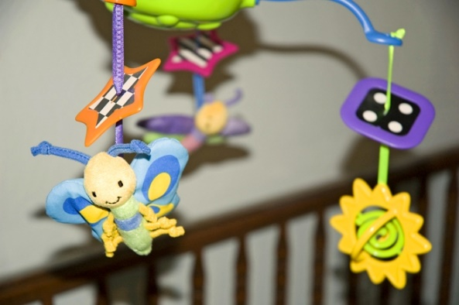
- Cots with bedding and mobiles
- Nappy changing area that is hygienic and safe
- Storage for bags, personal belongings
- Large mat area with space to crawl and play with toys. This must be able to be cleaned regularly
- Toys, balls, cloth/plastic or board books that have bright and bold pictures and different textures
Figure 1.3 A mobile is an example of a resource that is suitable for babies
- Area for messy play/eating that is tiled
- Cushions, mattresses
- Safe flat, grassed outdoor area with baby swings

Toddlers

They will also need a sleeping and nappy area but also close proximity to toilets for toilet training.

- Mattresses for sleeping
- Storage for bags, personal belongings
- Mat area for group activities like morning ring, story and music or movement
- Classroom can be divided into basic areas – creative activities, books, toys, blocks and ‘house corner’
- Need suitably sized tables and chairs for eating and creative activities
- Outdoors they need low jungle gyms and slides, tricycles or pushbikes and sand and water play

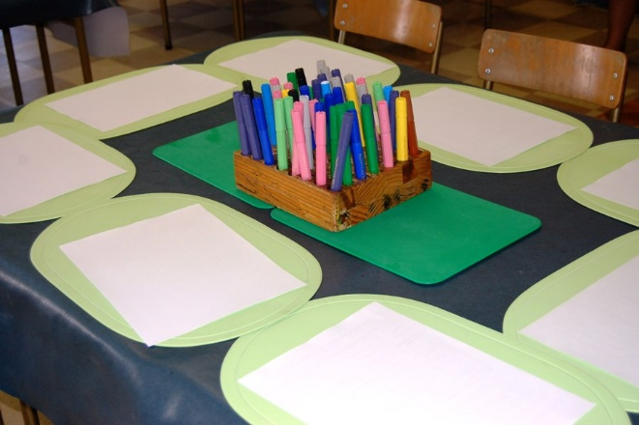
Young children
During this phase, the child will start to make sense of the information gathered through their senses. Meaning is attributed to objects, persons, sounds, tastes, and smells. The child acquires attitudes, social skills, language skills and most of the skills necessary for formal learning (e.g. following instructions).

They play, eat and sleep in the same area. However, they need to be near toilets so that they can learn to be independent and go as needed.

- Mattresses for sleeping
- Storage for bags and personal belongings
- Need suitably sized tables and chairs for eating and creative activities
- Mat area for group activities like morning ring, story and music or movement
- Classroom should have the following areas (can be provided on a rotational basis if space is limited) – fantasy, book, block, educational toys and games, numeracy and literacy table, nature/science/social studies table and creative activities.
- Outdoor area should have sand and water play, adventure play, movement exploration area, wheel toys and jungle gyms

DEFINITION
Adventure play: includes boxes, sheets and other movable items that children can use imaginatively in the garden. Equates to fantasy area inside.
Movement exploration: includes obstacle courses, balance beams, tyres, bats, ball etc, which allow children to handle objects and develop both gross and fine motor skills.
It is very important to bear in mind that this is a general guide only – every child is unique and each one has a different personal timetable of development. Often a child will be advanced in one area, but less so in another, for example, one child has an outstanding vocabulary and advanced reading skills, but doesn’t manage well with gross motor activities; another is socially confident but is behind in cognitive activities. You have to be aware of their individual needs, and provide them with resources that will allow them to enjoy their strengths, as well as ones that will gently develop their weaknesses.

Also, remember that within any group of children of the same age, there will be some who are many months older than others, and six months at this stage of life can make a very big difference to what a child can do.
Age | Appropriate activities and resources
2 year old | - Activities are focused around routines of eating, sleeping and toileting.  - Another area that is very important to a baby is the development and strengthening of muscles and muscle groups. The child needs to be able to roll over, sit, pull him/herself up against objects, crawl and stand up.  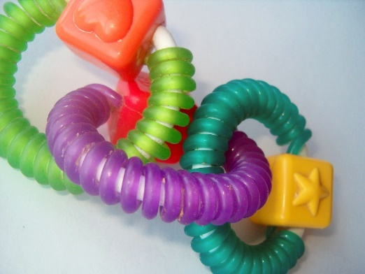  - Noisy toys such as rattles that they can grip easily.  - Oral exploration stage, so all toys etc must be able to be washed and cleaned to prevent the spread of germs.  - Language skills are being formed and the child will learn to speak during the first 3 years of his/her life. It will therefore be important to include activities that facilitate the learning of linguistic skills like songs, rhymes, animal noises etc.  - During the baby and toddler stages, the child learns through exploring his/her world in a physical concrete way. They use all their senses: seeing, hearing, feeling, tasting and smelling to discover the world around them. Children of this age needs to have access to objects of different shapes, sizes, colours and textures. Even food is an important object of discovery – some foods are soft, others textured and there are a large variety of tastes and smells to discover.  - Talk in two or three-word sentences and their vocabulary is expanding daily.  - They are forever on the move and everything must be examined and tasted.  - They have learned to jump and can climb up slides and jungle gyms.  - They can take a couple of steps on a balance beam.  - Enjoy looking at picture books and listening to simple stories and rhymes, as well as music and singing activities.  - They love make-believe games and play enthusiastically with props like toy stoves and telephones.  - They love using ‘real’ implements, like buckets and spades.  - They push and pull cars, and play with a soft ball.  - They thread large beads, make basic structures with blocks, can match simple shapes and do a three-piece puzzle.  - They will learn to use scissors and paint with a brush.  - They are not ready to play with other children, but rather beside them.  - They are possessive with their toys and find it hard to share.
3 year old | - Talk in sentences of three to five words. The two-year-old is “no” has turned to “yes” and they want to please you.  - Physically very active, they play on tyre swings, slides, jungle gyms, tunnels, and love obstacle courses.  - They enjoy ball play.  - They can count to ten and name common colours.  - They make towers and bridges with blocks, and can do jigsaw puzzles of six to ten pieces.  - They love Lego and other construction toys.  - They can do simple classifying and matching activities.  - They have mastered the use of scissors, and enjoy crayons, paint and clay as well as chalk and a blackboard.  - They are interested in books and can hear the same stories repeatedly.  - They love singing and playing with musical instruments.  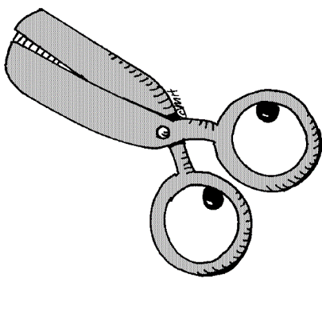  - They are more able to play with other children; they have greater self-control and are learning to share.
4 year old | - They speak in sentences that are more complex. They love to talk and are full of questions, demanding information about everything.  - They are extremely active and run around at high speed. They can ride tricycles confidently and enjoy balancing and climbing equipment, skipping ropes, hula-hoops and stilts.  - They like threading activities, building with blocks, playing with play dough or clay.  - They can do puzzles and games based on sequencing (e.g. smallest to largest), as well as sorting and matching in terms of numbers, size, texture and colour. They are building up the number of jigsaw puzzle pieces they can manage and need a range from four to 28.  - They are interested in books and recognise familiar words.  - They enjoy using musical instruments to play along with songs and make sound effects for stories.  - They love fantasy play, like setting up a pretend shop.  - They like playing with other children and can take turns and obey simple rules.
5 years old | - They can understand about 13 000 words, their thinking is more concrete and they like to argue and reason.  - They are more independent and can sustain their own play without constant supervision.  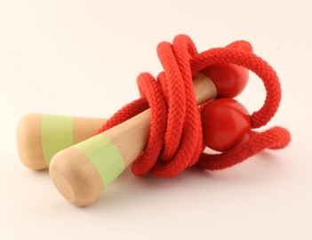  - Physically, they are much more coordinated, can jump with a skipping rope and catch a ball, and may start riding a bicycle with training wheels. They still play enthusiastically on all the swings and jungle gyms, and they like more challenging physical activities, like balance beams and Tarzan ropes.  - They can cut accurately with a pair of scissors, and need lots of opportunity to draw and paint. They like making constructions from boxes and other scrap materials. They enjoy taking apart and trying to put together old machines and clocks.  - They love being read to and also enjoy telling their own stories; it’s very rewarding for them if you write down their stories and make books. They still enjoy making sound effects and rhythms on musical instruments.  - They can do activities and puzzles involving classifying, matching, counting and sequencing. They enjoy card games, jigsaw puzzles, and board games like snakes and ladders. They still play with blocks and make-believe, with more complex ideas and stories. They invent fantasy games and organise other children to join in.
Appropriate learning resources according to age

As an ECD practitioner, you will need to be able to select appropriate learning resources to match the activities as well as the needs of the children in the class. There are so many resources available that it may sometimes be difficult to choose what you really need and what is appropriate. We will look at the criteria you should use to when choosing and buying resources.

Key elements
There are five key foundation stones on which every learning activity rests and thus which determine the resources chosen in an ECD classroom.

- They should encourage the children to learn while they are playing.
- The variety of resources should cater for all developmental areas.
- They should facilitate integrated development where possible by addressing more than one developmental area.
- They should be developmentally appropriate.
- They should encourage emergent literacy, numeracy and life skills

Types of resources
In the ECD playroom, we use many different types of learning resources. The different kinds of resources are used to develop different skills and to engage the interest of the children in the learning programme. The more variety there is the more you will be able to maintain the children’s attention. It is also important that they learn about the world around them – both natural and man-made elements.

DEFINITION
Learning resource: anything that is used to facilitate the learning process. This could be any of the following;
- objects such as books, toys, games, puzzles and blocks;
- plants and other natural resources that can be found (for example leaves and pebbles);
- people such as other ECD practitioners, experts and visitors;
- animals such as pets and farm animals;
- technology such as computers, tape recorders and CD players;
- visual aids such as posters and diagrams;
- resources for creative art;
- outdoor equipment;
- puppets, clothes or accessories for dress up and fantasy play; and
- bought resources (for example puzzles) or made resources (for example posters or musical instruments made by the ECD practitioner).

These resources can be catergorised as follows:

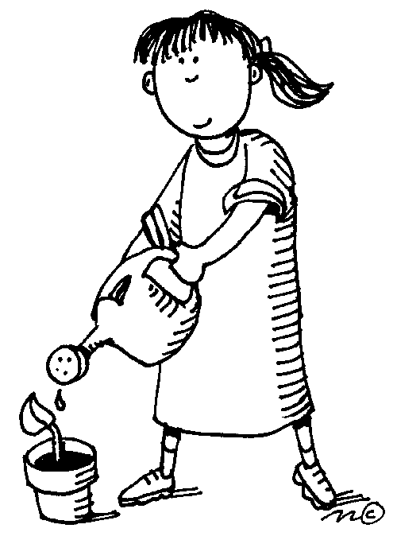
Natural

Young children need to be encouraged to develop a respect for and love of nature. For this reason, we include many different kinds of natural learning resources in the ECD playroom. For example, leaves for nature collages, seedpods and shells for sorting or beans and other plants that are grown from seed in the classroom. Pets and animals may be kept at the school or brought in to address certain themes.

They are most freely available and thus do not have to cost money. As an ECD practitioner, you can collect items or encourage children to collect leaves and other interesting items when they are out and about.

Improvised

Learning resources can be improvised or created to fulfil a particular purpose. For example, coloured blocks from the block play area can be used to sort into different coloured boxes to teach colours. The children’s blankets, chairs and tables could be used to build a ‘tent’ in the classroom where they can play ‘camping’ or ‘picnic’. Children are very creative – by providing them with basic resources, we allow them to discover new things and new ways to apply old objects. Adventure play in the garden is one such activity that addresses this need.

As an ECD practitioner, you will need to use your imagination too and improvise as much as possible when working with themes. Your fantasy area can be transformed into a vet’s surgery with a few animal soft toys, a desk and some medical items like stethoscopes and bandages.

Scrap

Often learning resources do not have to be expensive and can be developed from scrap materials. For example, you can involve the families by requesting them to help you gather empty boxes of breakfast cereal, plastic tomato sauce bottles, empty peanut butter jars, etc. You can use these scraps to create a corner inside or outside that could serve as a make-believe shop. The children can take turns in being the shop owner and the customers. You can also convert a big box into a doll’s house by cutting a door and windows into the sides. The children can get involved too and help you to paint the box during a creative art activity.

Even tables and chairs that are strong enough for adults to sit on can be made from paper maché. It may require effort and time but can also be very beneficial in teaching children to recycle and conserve our precious resources.

did you know?
ELRU has a great book, Learning with scrap, which has many ideas that are geared towards ECD.

People

Parents, grandparents and community members can also be valuable resources as they can share their experiences e.g. a mom who is a nurse could come to school in uniform and talk about her work when you are busy with a theme of ‘people who help us’.

Commercial

The ECD playroom also includes learning resources that may need to be bought. Examples include jigsaw puzzles, picture books and board games or replicas of office equipment such as small computers, cash registers or cameras. It is often very tempting just to buy resources; however, many of them are imported and very expensive and your budget will often not stretch to accommodate all that you would like.

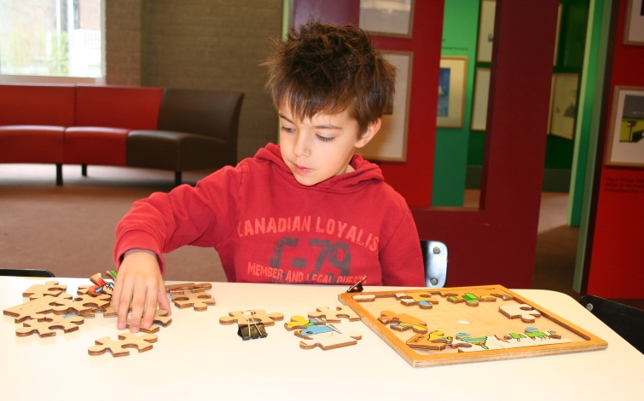
Figure 2.1 Puzzles are an example of commercial resources that you cab buy
Selection criteria when buying resources
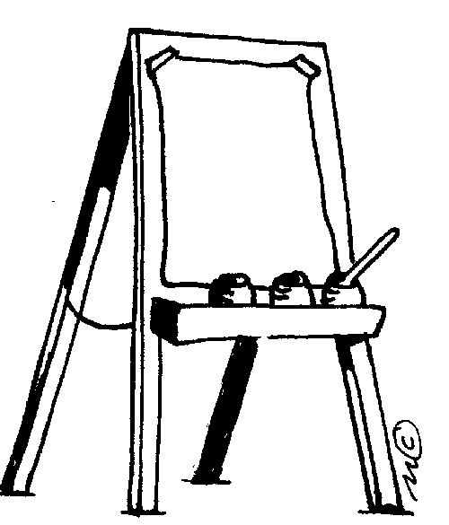
- Are they safe? This is the most important criteria and is often age dependent. A baby would choke on small pegs from a pegboard, whereas a young child knows not to put it in their mouth.
- Is the equipment appropriate? Does it adequately address the age and stage of the children who will use it?
- Are they suitable? The children in the class should be able to use it comfortably e.g. chairs and tables that are the right height and size.
- Do they address specific skills that children need to develop? Children should be learning self-help skills such as dressing or tying their laces.
- Do they have more than one use? An easel can be used for painting and drawing activities both indoors and outdoors. You can also use an easel to display pictures.
- Are they free from stereotyping? Children should not be exposed to stereotypical books and toys that entrench gender, cultural or racial bias. (ELRU have many suitable books as do Dorling Kindersley).
- Do the resources provide for a balance of activities? Balance between more active and more passive activities, balance between individual and group use for young children or balance between too easy and too difficult.
- Is it interactive? Toys should encourage active participation, as we know that this is the only way that children learn. Battery operated toys are generally not suitable but there are exceptions. Ask yourself if the play in the toy or in the child?
- Are they attractive? Children naturally gravitate towards brightly coloured items.
- Are they easily maintained? Resources should be cleaned regularly and should have smooth surfaces that do not trap dirt and germs. Jungle gyms that are painted will peel and look unattractive whereas pre-treated wood may not look as colourful but does not require much attention.
- Does it cater to the interests in your group? Will the children enjoy using it? Unless it will be used, it is a waste to buy a toy. Certain toys have more appeal at certain ages.
- Are they both familiar and unfamiliar? While children do like to feel secure and use resources they know well, they also need to be challenged and to learn further skills by handling resources that are not familiar.
- Are they classic? Resources that have stood the test of time include building blocks, dolls, Lego etc. Avoid buying the latest fad toy, as they are often not very suitable and have a limited life span in terms of appeal. These toys are often linked to movies or TV programmes that are soon forgotten when the latest one is being aired.
- Are they economical? Sometimes it is better to buy a more expensive toy that is stronger as it will last longer than the cheap toy that breaks within a few weeks.
- Are they easily available locally? Toys and books that need to be ordered from overseas will be expensive and the ordeal in getting them may not be worthwhile. It is also better to actually see a resource and handle it, before deciding that you would like to purchase it.
- Can they be adapted if need be to accommodate any special needs in your class?
What do we have that is similar? Are you buying it because it looks good or because you need it? There are often many resources available on a particular theme e.g. ‘transport’, and you may find you have enough books, toys and puzzles to cover this theme but need more resources for ‘under the sea’. It is wise to make lists of needs rather than just to purchase for the sake of it.

This is one of the most important criteria as briefly discussed in the previous topic. Safety may depend on the age group- for example beads are suitable for three year olds but babies would choke on them or on the resource itself – for example any item with sharp edges could be dangerous. We have outlined some important safety aspects below.

Safety
Safety is an extremely important issue when it comes to buying, making and maintaining resources. Become aware of all the dangers that resources can present, and be vigilant in looking out for them. Many toys and games that can be bought have age guidelines that you should take into consideration.

Make sure that the resources are not made with the following dangerous elements:

- Toxic paint
- Small bits that can be swallowed by little children
- Brittle plastic or glass that will have sharp edges when broken
- Sharp points: avoid pins, staples and wire
- Things that can cause injury when thrown, for example arrows must have soft cork or foam tips
- Working parts that can pinch fingers or catch hair

When installing fixed outdoor equipment make sure of the following:

- The equipment is installed on grass or another soft flat surface – never concrete
- Swing seats are not made of hard or heavy material
- All the wood is smooth to prevent splinters
- There are no climbing areas that would allow children ages three to six to fall more than one and a half or two metres
- The fixed equipment is very secure in the ground
- There are no sharp edges, broken parts or loose bolts
- There are no openings that could trap a child’s head
- There is no part of the equipment that could cause scissoring or pinching injuries
- There are no toxic materials used as preservatives

Regularly do the following maintenance checks:

- Check for broken parts and sharp edges
- Sand sharp or splintered edges on wooden toys and equipment
- Regularly check outdoor toys for rust
- Make sure that equipment to be stood or climbed on is still sturdy
- Check for worn rope or chains
- Check for rotting timbers
- Ask if the resources are right for the age group. Things safe for the older age group may be dangerous to the little ones.

When supervising the children

- Instruct them carefully about what they can and can’t do on equipment
- Enlist children’s help in setting up riding rules such as “no crashing into one another”
- Foster older children to help care for littler ones
- Teach them to put things away and treat resources such as books with respect
- Stand or sit near the equipment where safety is a consideration
- Never allow young children in paddling pools unsupervised
- Check that there are no foreign objects in the fall zones under and around fixed equipment
- Limit turns on equipment in great demand – set up a one way traffic system to avoid collision
- Always cover the sandpit to prevent animals using it

Durability
As you have seen, making sure that the large equipment is strong and durable is a big part of making sure that it is safe.

With smaller resources, too, it is important to make them strong and durable, so that you do not waste your precious time making something that is destroyed a short while later. ECD resources are going to be used by many little hands and they need to be tough. You want them to keep looking good too – it is demoralising for you and for the children to see toys and games that look worn out and shabby. Resources need to be strong enough to survive the wear and tear of everyday use

To make sure that the resources you make are durable, choose your materials wisely.

- Don’t use flimsy things that will bend or tear or break easily. Use strong raw materials like tough plastic bottles and containers, wood, reinforced cardboard, pebbles and stones.
- When you make puzzles, card games and board games out of thin cardboard, use good quality glue so that pictures don’t peel away. Strengthen them and keep them clean by laminating them with adhesive plastic, or have them laminated professionally. While it may seem expensive, it is economical in the long term as the resources will not constantly need to be replaced.
- When painting toys, cover the paint with a layer of varnish.
- Keep each puzzle and game that has small parts in its own strong box and reinforce the corners of these boxes.
Teach the children to put things away in their proper places so that there is no danger of losing parts or of them being trodden on

We need to think carefully of the images and ideas that we are exposing the children to when using resources. Research has shown that children develop attitudes to colour and gender very early in life: by the age of two they notice skin colour and between the ages of three and at the age of five they attach values to it – values such as that you are a more capable and powerful person if you have a white skin.

What do we mean by anti-bias?
A bias is the same as a prejudice – it is a judgement about people based on a pre-conceived belief about the group that they belong to and not on fact or who not they are as individuals. A bias means that your expectations of people are defined by their race, culture, religion, gender or disabilities.
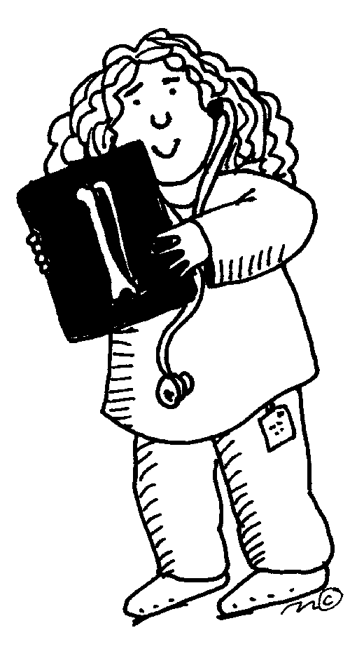
The first and strongest influence on children is their parents. Then they are influenced by the many messages around them – at the ECD centre, from friends, from television, from advertising, in books and in comics. Children model the behaviour they see around them. If adults think different roles and behaviours are suitable for boys and for girls, then children will also do so. If adults believe that some cultures are superior and others are inferior, this message will be passed on to their children. ECD practitioners have a large influence on children in their class as they are role models and the children spend many waking hours in their company.

ECD practitioners thus have a responsibility to ensure that the resources used in their classes do not reflect bias but show images of female doctors who are black or stay at home dads. What children don’t see plays just as much of a part as what they do see; if they don’t see disabled people or black people in successful roles, that will play a part in their expectations of people in those groups.

What is culture-fair?
It is very likely that the ECD centre where you work will include children from several different cultural backgrounds. Being “culture fair” means recognising, respecting and affirming all the children’s different cultural backgrounds. Different cultures vary in some important areas of life:

- the size and structure of the family
- language
- food and the way of eating
- dress
- discipline
- customs and traditions
- religion

Children often tease others for differences like language. They need to be taught by your example to understand and value cultural differences.

Simple ways to do this would include providing books on various cultures, celebrating festivals from all the different cultures of the children in your class. You can ask the parents of the children to assist by helping you understand and plan for these celebrations. They can provide appropriate food or clothing, candelabra’s etc that can be used in your classroom. A parent could visit your class dressed in traditional attire and explain the meaning of the festival. “Make and bake” activities could focus on the different foods.

In pictures, books and games, it is important to have positive visual images of the groups that make up society. Whatever their characteristics or background, children should see positive images of themselves in the resources. An excellent example is the pack of “Happy Families” playing cards from ELRU, which show many different types of families.

When making resources such as jigsaw puzzles, card games, matching games, etc, make sure that the pictures you use reflect the children in all their diversity. Include pictures of cultures from all over the world particularly with children over four years of age, as they are ready to learn about the diverse world.

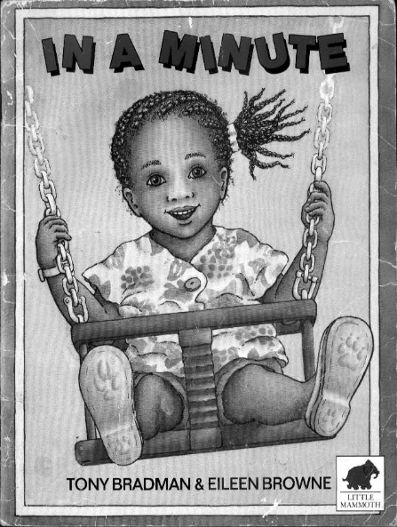
- In the book corner, children need images they can relate to. Photographs of the children themselves are a very useful resource and give them an enormous sense of affirmation.
- Make books using photos you take of them, for example about an outing.
- Parents can write captions in languages other than English for homemade books and displays.
- In art, mix paints in all the different skin tones so that the children can produce a representation of themselves or others.
- In the imaginative play corner, reflect a variety of cultures in the dressing up materials, play foods, props and in the dolls.

Learning resources to encourage a gender fair environment
If adults classify toys along gender lines, children will too. In a research study, a group of psychology students were asked to examine a list of fifty toys, and to mark which ones were appropriate for boys, which were appropriate for girls, and which were appropriate for both. The results were that there 24 toys were marked for boys only and 17 for girls only. The boys’ toys included guns, doctor sets, tricycles, remote control cars, microscopes and blocks. The girls’ toys included teddy bears, phones, dolls and dollhouses. The study then analysed the kinds of development promoted by these toys.

The boys’ toys encouraged being social, constructive, aggressive and competitive, while the girls’ toys promoted being nurturing and creative. This research shows that different toys promote different skills, and so have a profound effect on a child’s development.

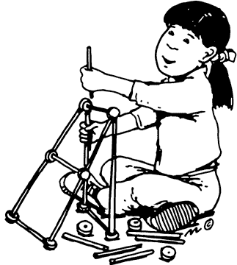
Support a non-sexist viewpoint in your playroom – especially in areas that are traditionally for girls (like the home corner) or for boys (like science or construction activities). Boys and girls should have equal access to all experiences and should be encouraged to try out the various activities.

Be conscious of the messages that are given out by the children’s books. Is there a fair distribution of stories centred around boy and girl characters? What sort of activities are men and women shown to be doing? If most of your books show only the traditional roles, then look for books in the library that show girls and boys, men and women, who are breaking the stereotypes.

Make books yourself, as well as posters, games, cards and puzzles that use images showing both sexes in a wide range of roles, for example, a father staying home to care for the children or a woman police officer.

Learning resources to encourage a disability fair environment
Children with disabilities have the same need as the others to see themselves reflected in their school environment. They need to be surrounded by positive role models and to have a positive view of themselves. It is also important for other children to see images and hear stories about disabled people so that they understand and accept them.

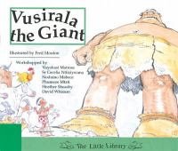
Try to find books that show people with disabilities in active roles. Are there any books in your library that have a disabled person as the main character? Look for stories that have characters who are disabled but their disability is not the main focus of the story. (An example is Vusirala the Giant, a South African story in which the little girl who defeats the giant walks with crutches.) Again, make books yourself using photographs of all the children in the class.

If you have hearing-impaired children try and provide many stories on tape for them to listen to. For visually impaired children make tactile “touch me” books with textured pictures.

Display pictures of children with different disabilities. Include pictures of them interacting with others who are not disabled. Look for pictures of disabled adults in a variety of roles, as parents, sportspeople, teachers, etc. When you make dolls and puppets for imaginative play, you could add some characters wearing glasses, or a hearing aid, or in a little wheelchair.

Make posters with words like “hello”, “I love you”, “happy” and “sad” in different languages, and include sign language and Braille.
Are resources suitable within the community context?
According to didactic or teaching principles, we work from the known to unknown or familiar to unfamiliar. This can also be applied to resources.

Many of the books, games and puzzles that are produced overseas contain images that are not familiar to many children within a South African context. A typical example is of winter being depicted with snow – for most children in our country this is not a reality. As ECD practitioners, we need to be aware of our community context and provide the children in our class with more familiar images. This does not mean that we cannot expose them to snow for instance, but we need to look at their age and developmental stage and interests to ensure that we are not confusing them.

There are many resources that can be bought that are made in South Africa and have images that are more familiar to our children. (A list of these resources has been included at the end of this unit standard for your convenience.)

You will still need to use your discretion and understand the context of the children in your group as children living in a township will have a different understanding to those who living in leafy suburbs nearby.

Some suitable children’s books
The following books are all published by the Anti-Bias Project of the Early Learning Resource Unit and are available to purchase from ELRU directly. They are well illustrated and include colour photographs.

- Anjtie – Xhosa, English, Tswana and Afrikaans book – about a girl who lives in Genadendal and what she gets up to, including driving a donkey cart.
- Nkqo! Nkqo! – Xhosa, English, Tswana and Afrikaans book – various families of different cultures are captured in daily rituals.
- They were wrong! – about the prejudices that exist regarding various cultures in Cape Town.
- At School, What if…? – about Ncebakazi who uses a crutch and the fears she has of going to a mainstream school for the first time.
- Mhlanguli – Xhosa, English, Tswana and Afrikaans book – about a boy who lives in Khayelitsha and does ballroom dancing as a hobby

Resource | Bias  Yes or No | Type of bias | Explanation
Traditional Ladybird storybook of Cinderella, which is written in English.
Snap game of occupations showing different races of male doctors, policemen and firemen and female pictures of nurses and teachers
Domino game of food items – pasta, salad, hamburger, rice, chicken, sushi and Chinese food (bowl with chopsticks)

As an ECD practitioner, you may choose your resources very carefully according to the guidelines we have discussed but you may still find that they are not suitable for all the children in your class. You may need to adapt or change them to ensure that they are:

- Suitable for any special needs in your group
- Appropriate to the particular activity
- Safe and durable
- Familiar but provide challenges and expand the child’s life-world experiences
- Bias free
- Developmentally appropriate
- Reflect the interests of the children in the group

Ideas for children with special needs
These adaptations will depend on the special needs of each child – even two children with the same disability may have special needs that differ. This topic is also discussed in the study guide, Developing learning programmes to enhance the participation of learners with special needs. If you have a child with severe disabilities, it would be wise to contact their physio or occupational therapist to get advice as to how you could adapt your equipment to assist the child best. Below are some suggestions and ideas but adaptations are only as limited as your creativity and problem solving abilities!

Creative art activities

Children who have poor fine motor skills and pencil grip can be assisted by enlarging the grip.

Take a small soft rubber ball and make a hole through the centre. Push the paintbrush handle into the hole so that it fits snugly. The child can then grasp the handle by holding the ball. You can also take the foam from a hair curler and put the paintbrush handle into the hole in the foam. You may need to secure it with tape. If you don’t have a hair curler, you can trim a piece of sponge and tape it to the handle.

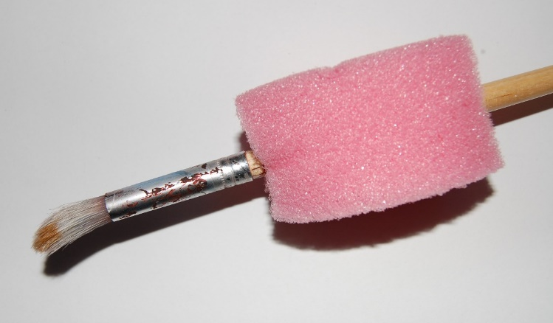
Adapted paintbrush
Soft triangular shaped rubber grips are available commercially for kokis and pencils. Children may also find it easier to use thicker, triangular or animal shaped crayons which can be bought locally.

Adaptive scissors are available on the internet to suit various needs. The ‘spring scissors’ are very good for children who have poor fine motor skills. While they may be expensive, it could be worthwhile investing in one or two pairs. Provided that they are well cared for, they should last for many years.

Educational games and toys

Children with poor fine motor skills may need knobs glued onto puzzle pieces so that they can more easily grip and place them.

Children with poor spacial and cognitive skills may need to have puzzles that have a backing board and correct sized frame. The outline of the pieces can also be traced onto the backing board to assist in making them self-corrective. Always ensure that there is a picture of the completed puzzle to copy. (You may need to scan the puzzle to do this as many of the ECD wooden puzzles do not come with boxes with the picture on them.)

You can facilitate threading activities by providing sosati sticks to thread onto rather than string that is floppy and difficult to manage. Make sure though that any sharp points are cut off the sticks.


Books

Children who have poor eye-sight may need to have magnifying glasses available to look at pictures. They also enjoy books with textures and large bold pictures. They see the contrast between black and yellow best so yellow acetate sheets can be provided as filters for them to place over words that they want to read.

Outdoor equipment and toys

Tricycles are a better option than bicycles as they are sturdier otherwise training wheels may need to be fitted to bicycles to provide stability. Straps can also be attached to the pedals so that the children’s feet stay in them.

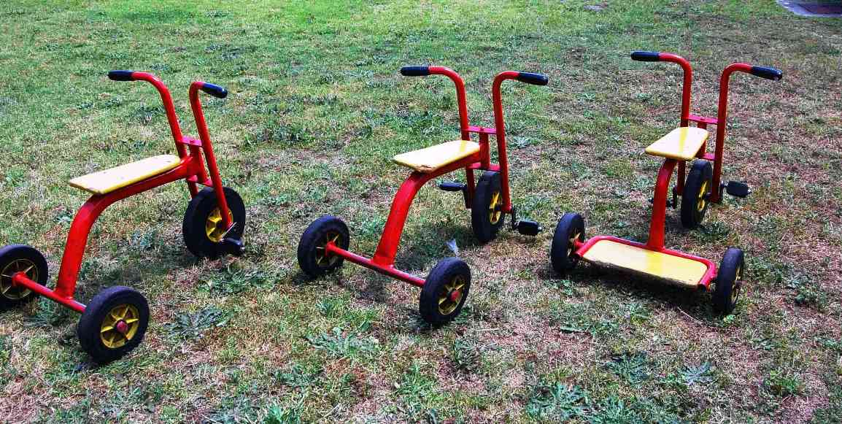
Tricycles are a good option for outdoor equipment as they are studier than bicycles

Sand and water play equipment should be provided in many sizes and shapes to accommodate poor grips. Children who are on crutches may need to be provided with a higher chair so that they can sit and use both hands at a water trough. Children who have difficulty sitting unaided can be provided with a ‘floor chair’ so that they have a backrest.
Adapting to a specific activity
Many ECD centres are run on very limited budgets and so ECD practitioners are not free to buy the resources that they would like. While some ECD practitioners just accept this and limit the learning in their class, to what they have available, others use their creativity and create learning opportunities. Below is a case study of one such teacher.

Case study
Sindy was an ECD practitioner in a class of 20 children (four-year-olds) at a local ECD centre. Her theme for the week was shopping. She looked through the resources in the storeroom but could not find any ‘pretend’ money or cash register but she could find empty food containers. She thought carefully and decided to involve the children in making the money as an art activity.
Firstly, they discussed the concept of money in morning ring and looked at money to see what it looked like. The children were made aware of the colours, pictures, writing and numbers on coins and notes.
The coins were made by getting the children to cut out different sized circles that she had traced on cardboard and covering them with foil. The children looked at real coins and took blunt pencils and drew pictures and numbers into the foil. The paper money was made by photostatting various notes on a light setting. The children were then given crayons to add to the pictures and dye was washed over them. They dried the papers outside, before doing the other sides of the notes. These notes were then cut out.
The house corner soon was transformed into a shop. A bookcase was used to display all the “food” and a desk and chair were provided for the cashier as well as an old calculator. The children were able to shop and use their money to buy groceries. The children loved the fact that they had helped.
When Sindy evaluated the activity, she realised that the children had stimulated the following areas of development: fine motor, social, cognitive, emergent literacy and numeracy, language and creative skills.

As an ECD practitioner, you will often need to use found materials to create learning opportunities.

Here are basic examples:

- Sorting game: need various coloured items from the class e.g. crayon, block and counter etc. – red, blue, yellow and a yellow, blue and red chair.
You want the children to sort according to colour. You could make a game of it in morning ring, giving each child a turn to pick up an item off the mat and place it on a chair of the same colour next to you.
- Matching game: you need two of each item e.g. block, crayon, scissors, cup etc, and a box.
Lay out one of each item on the mat. Children take an item from the box and put it next to the matching item. With older children you can use pictures.

Safety and durability adaptations
These are especially important if you are dealing with babies and toddlers as they are in the oral phase and explore their environment by putting objects in their mouths.

Safety concerns

Dolls, puppets and soft toys
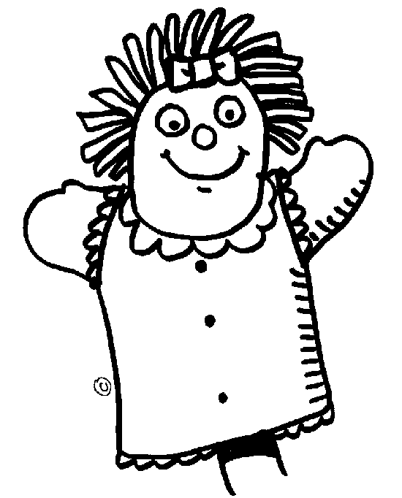
Ensure that the eyes are well attached and stitched on and cannot be bitten off. If need be, remove the eyes and rather draw them on with koki. Any detachable parts of clothes that can be swallowed should be removed. Make sure that the items are firmly stitched and that the stuffing cannot be removed and swallowed.

Blocks, toys, games

Make sure that they are too big to be swallowed. They should not be painted with anything toxic and stickers should not be easily removable. Look carefully to see if there are any parts that can pinch skin inadvertently while they are being used. They should not be made from anything brittle or breakable and should have no sharp corners or parts.

Art materials

No toxic paints, dyes or crayons. Make sure that you buy suitable resources from reputable sources and read the labels. Scissors should have rounded blunt ends, any toothpicks, sosati sticks etc should have the points cut off.

Durability issues

You will need to make sure the resources you use are durable as children’s skills are still developing and they can be quite rough without intending to do damage. Even bought resources may need to be laminated to ensure that they last as long as possible. Resources that are flimsy have been a waste of time and money as they will not last the wear and tear of young children. Sometimes it is more economical to spend more initially as short cuts will be costly.

Here are some tips and hints:

Use good quality base materials that are strong and sturdy, for example stones, strong plastic bottles, buttons, bottle tops and thick cardboard. Avoid using paper.
When painting items such as blocks, tins etc, paint a PVA or primer coat first. Your coloured paint will go further and the colours will look brighter and neater as they will go on more easily. When you have finished painting, cover the resource with a layer of varnish as this protects it from fading and peeling.

Use quality glue at all times. Cheaper glue does not stick for long.
Where possible, sew items. Puppets made from felt that is sewn together and has eyes etc that are stitched on will last much longer than those where glue has been used.
Paper mâché works best if you use white wood glue rather than flour as part of the pulp. When your paper mâché item dries, it will be almost as hard as wood. This is very important when making puppet heads or furniture items.
Always laminate cardboard puzzle pieces, posters, pictures or games. If you are not good at applying the plastic evenly, budget to get it done professionally as it will be economical in the long run.
Where possible, keep pieces of games and puzzles in boxes. You can strengthen boxes with clear packaging tape and cardboard pieces. Alternatives to boxes are plastic throw away containers from ice-cream, cheese wedges etc.

It makes no sense to spend money either buying or making resources for them to be destroyed in one use.

Adapting resources to be bias-free and familiar
As an ECD practitioner, one of your many roles is to expose children to a variety of resources that are free from cultural bias. In our multi-cultural country, it is vital that children learn tolerance and respect for one another as well as an appreciation for diversity. You may need to adapt or create resources to ensure that they do not reinforce any gender, culture or racial stereotypes.

Songs, rhymes and poems can be adapted by changing words and names to suit a South African context. This is also valuable in making them more familiar. One needs to be very careful though that in changing any words, you are not changing the basic meaning, rhythm or rhyming of words.

Here are some examples:

- “Do you know the muffin man…..who lives in Drury Lane?’ The words can be changed to
“Do you know the pizza man….who lives in Tableview?”
- Very English names could be changed too. “Mary had a little lamb” could become “Thandi had a little lamb”

Children love to be consulted in the changes and often come up with very imaginative suggestions. Five-year-olds who are comfortable in a language naturally engage in this type of activity as part of their developmental milestones.

Remember though that it may confuse children if you are reading from a book and merely change names. Children who are developing literacy skills may go to the book later and not be able to match the name they heard to the print. A better option is to use a story as a basis and tell the story rather than read it. You can contextualise and localise the content and names using suitable illustrations or props that you have made. This approach is often used in theatre, for instance at Maynardville every year when Shakespeare plays are presented in contexts that are more modern.

While you may not be able to change games and educational toys, you can use the base ideas to create your own resources. The concepts below are inter-changeable and are meant to get you thinking of your own ideas…

- Lotto – instead of animals that are not endemic, you could have lions, hippopotami, giraffes etc.
- Dominoes – use matching pictures of different cultural items or food
- Puzzles – use pictures depicting local scenes or people
- Flash cards – have fathers hanging up washing, women who are doctors etc.
- Snap cards – use pictures of groceries including items like mealie-meal, pasta, samoosas etc.

Puppets and dolls can be adapted by changing their clothes or accessories to make them bias-free. Here are a few typical examples of adaptations that can easily be made.

- Males can wear pink shirts
- Wire glasses can be added to stimulate awareness of special needs
- Not all grannies have grey hair and buns – change the hair on a bought puppet by colouring it with a koki

When creating your own resources you can make puppets that are male nurses or female police officers. Use different flesh tones to depict various races.

Adapting to needs and interests
We need to meet the devoplental needs and interest of children in order for them to gain the maximum learning opportunities out of an activity. Three-year-olds who are very egocentric and show mostly interest in the things they experience would not be interested in a theme or activity based on travelling into space. Five year olds though would be interested as they can conceptualise the ideas better.

Here are some suitable themes for various ages. Please note though that interests also depend on the media that the children are exposed to every day. Think of how popular comic characters become when a new movie is released, or the hype around the Olympics or soccer in 2010.

quote
“The wise adapt themselves to circumstances, as water moulds itself to the pitcher.” – Chinese Proverbs

Toddlers
- Me and my body  - My family  - My home  - My school  - Healthy food | - Keeping clean  - My pets  - Colours  - Sounds around  - Big and small

Young children
- My body – uses of limbs etc  - Feelings and moods  - Senses and disabilities  - My extended family  - Types of food  - Babies  - Shapes  - Farm animals  - Wild animals  - Baby animals  - Animal homes  - Transport – land, air, sea | - People who help us  - Stranger danger and safety  - Spring  - Summer  - Autumn  - Winter  - Opposites  - The beach  - Under the sea  - The forest  - Night and day  - Hygiene and health

Pre-schoolers (5–6 yrs)
- Life cycles  - Under the sea  - Strange and different animals  - Mammals vs. Reptile  - Insects  - Dinosaurs | - Weather  - Seasons and how they change  - Pollution and littering  - Professions  - Mining

These theme ideas are based on an adaption of the learning spiral from Jerome Bruner who is a contemporary educational theorist. He is one of a group of constructivists who believe that all people are responsible for building their own ideas and knowledge. We do so by building on what we already know and understand and it all starts with knowing ourselves.

Here are some ideas and guidelines for learning resources that are easy to make, free of charge but as effective as any you can buy. Many of them you will be able to make in your spare time, but some of them are more labour intensive, like making strong cardboard furniture for the house corner or tyre swings and ladders for the outdoor area. For these, organise a work party and ask the parents to come and help – working together on such occasions is very sociable and an excellent way for the ECD community to get to know each other.

Collecting materials
You can collect these from family and friends. A good way to get parents involved is to send out a list of things that you need. This may need to be done at regular intervals during the year to remind them.
Objects found in nature:

In addition to these recycled materials, also look for natural materials. Enlist the help of the children in making this collection.

- dried seaweed
- driftwood

- feathers
- eggshells
- seedpods
- sticks
- bamboo
- stones of different sizes
- animal and bird bones
- semi-precious stones
- fossils
- cocoons
- nests
- eggs
- insects
- growing plants

Waste material

In addition to all these materials found in people’s homes and in nature, there is an amazing variety of materials discarded by shops and factories. Make contact with businesses in your community to find:

- From store managers: discarded cardboard shelf displays and cardboard boxes
- From container and packaging companies: large boxes, tubes, pieces of cardboard
- From builders: off-cuts of wood, lino, Formica
- From framing shops: pieces of frames and thick card
- From clothing manufacturers: materials, buttons, buckles, spools for thread
- From liquor stores: sturdy cardboard boxes and beer trays
- From leather and shoe manufacturers: leather scraps
- From paint companies: colour cards
- From photo shops: film canisters
- From newspapers: rolls of newsprint paper
- From carpeting companies: rug samples
- From tyre shops: inner tubes and old tyres
- From tobacco stores: unique wooden and cardboard boxes
- From wallpaper companies: wallpaper sample books
Made resources for various areas
Book area

Make books by sticking pictures on cardboard pages, punching holes in them and lacing them together. Choose pictures that tell a story or have a theme, and write simple captions. For strength, cover the pages with adhesive plastic.

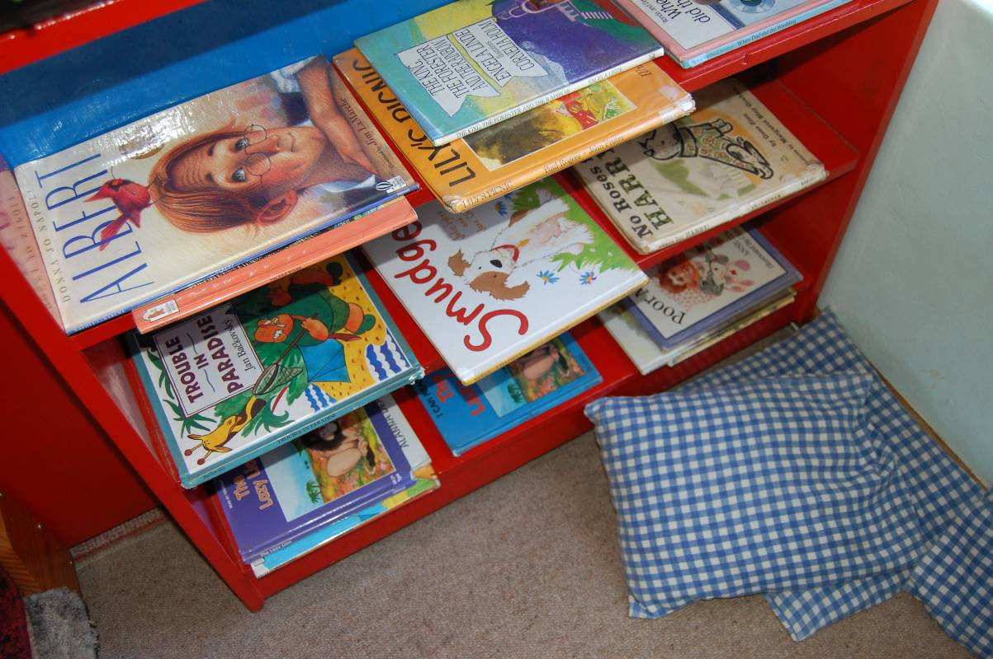
Figure 3.3 The book area

Making puzzles and games

- Pictures found in magazines can be used to make a variety of puzzles. Reinforce them by sticking them to cardboard and covering them with adhesive plastic.
- A series of pictures that have to be put in a logical sequence (before and after)
- Pairs that match rhyming words (pictures of car and star); or match a word with a picture (the word car and a picture of a car);
- Match animals to their habitats: (cards with pictures of animals and others with pictures of veld, sea, sky – where do they live?)
- Make picture dominoes
- Make a board with six squares and glue a set of pictures on to each square. Then, on separate pieces of card, glue associated pictures: which two belong together? E.g. rain – umbrella, knife – fork; hammer – nail etc
- Make your own card games by sticking pictures on to playing cards that can be bought very cheaply
- You can also draw the pictures for matching games. A favourite is “Whose tail is this?” Cut cards of the same size and draw a pencil line down the middle of each card. Draw a different animal on each card using coloured a pencil, making sure the tail starts at the pencil line. Now cut each card in half. The tails must be matched with the right animals.
- “The outline game”: draw the outline of objects on a piece of strong paper and keep the objects in a container. The objects must be placed on their correct outline.
- Make a set of cylinders, boxes or tins graduated in size for nesting or stacking
- Use sets of objects like blocks, buttons, beads, stones of different sizes, pieces of fabric of different textures, and all sorts of household objects, to make classifying games. They must be sorted in terms of size, shape, colour, texture, or purpose.
- For smaller children make a box of objects in pairs: scramble them up and find the pairs
- Use pairs of objects that are alike but different, to talk about distinctions like smaller/bigger; different colours; heavier/lighter, and so on

Fantasy play area

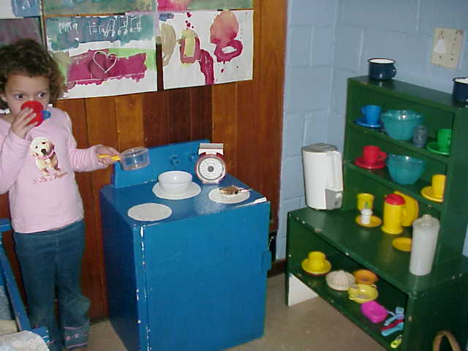
- Make play money out of green, brown, pink or blue paper
- Make fruits and vegetables, cups and saucers, etc. for the shop and the kitchen out of paper mâché: soak torn up cardboard egg boxes with water and white glue; mould the mixture into shapes and let it dry hard, then paint them – this recipe makes objects almost as strong as wood.
- You can also make puppet heads from paper mâché, and sew glove bodies with scraps of fabric and buttons.
- Make rag dolls out of bits of fabric, stockings and wool.
- Equip the home area with a stove, doll beds, and dressing table out of strong reinforced cardboard. Cardboard box furniture is very cheap to make but it takes time, so set up a box furniture workshop and ask the parents to help. The important thing is to make sure it is very strong by reinforcing it well: the cardboard needs to be six layers thick. Stick it together with white glue and use a sharp craft knife to create storage boxes, a toy stove, cupboard, television, cot, table etc

Outdoor play

Creating these resources is another big job and another great opportunity for a parents’ work party.

- To make a rope ladder, drill holes at each end of thick narrow planks and knot a heavy nylon rope through the planks. Tie it up in a tree.
- Make a Tarzan rope by tying a big knot at the bottom of a thick rope. Hang in a tree for children to swing on.
- Make a seesaw by balancing a wide plank across a thick tree trunk laid on its side. (This piece of equipment always needs supervision.)
- Make a punching bag by stuffing a large bag with rags and tie it up in a tree so children can punch it
- Make stilts out of two coffee tins: turn them upside down, make two holes in them and attach strings at the right height for the child to hold.
- Make a petrol pump by attaching a piece of plastic pipe to a large plastic container.

Tyres

Make the most of tyres – they are the most useful resource imaginable in the playground, and old tyres can be obtained for free.

- Tyres half buried in the ground form a tunnel
- Dug deeply into the ground they make a very good low fence around dangerous areas such as swings, as well as providing a balancing beam
- Bolt a set of six tyres together and attach them to two sturdy upright poles to make a climbing wall
- Fill a large tyre with sand for sand play. Stack three on top of each other and fit the top one with a plastic basin for water play. Fill one with soil for a tyre garden.
- Tyres make the best swings, comfortable and safe
- Make a balancing beam with a strong plank across two tyres
- Combine tyres with cement tunnels, trees, ropes and ladders to make obstacle courses
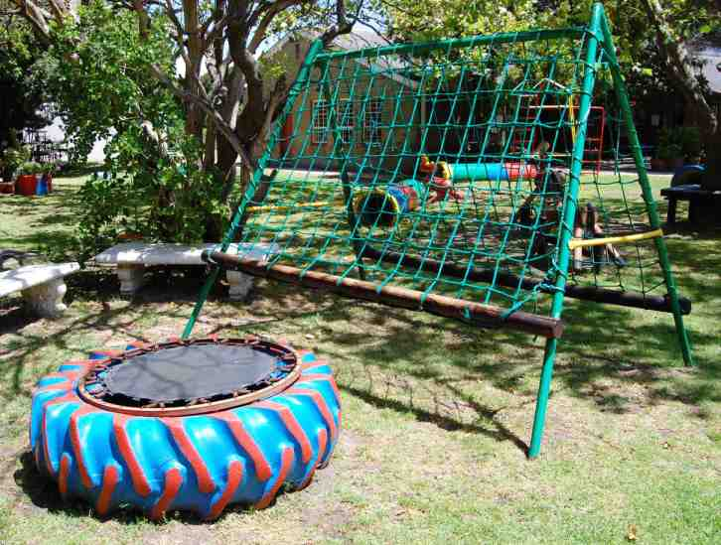
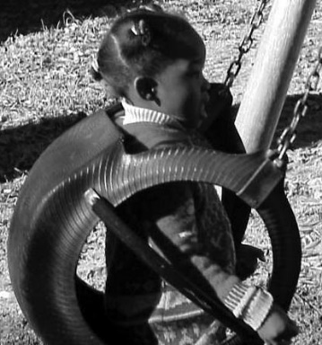
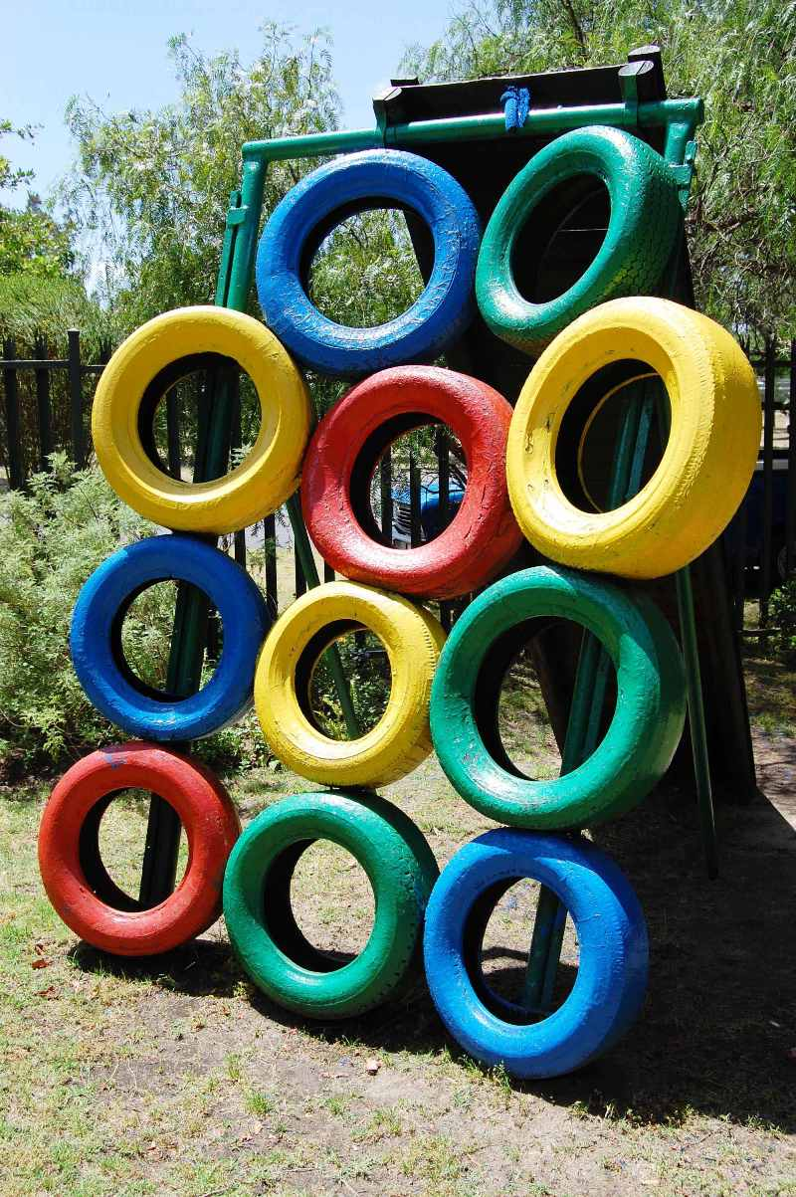
Tyres can be used in a number of creative ways

Science and discovery area

- Make a hanging scale by hanging a coat hanger at the child’s height, and attach plastic containers to each side with string
- For spades, cut a tough plastic bottle in half lengthways, shaping it to make a scoop
- For funnels use the tops of plastic two litre bottles, and for measuring cups the bottoms of the bottles
- For sieves, make hole with a piece of hot wire in the bottom of the plastic bottles

Block play

- Make blocks out of off-cuts of wood; make squares, rectangles and triangles in a variety of sizes. Sandpaper the surface to make sure that they are free of splinters
- Make a big floor cloth and paint a street plan of a town with roads for the children to use for their cars
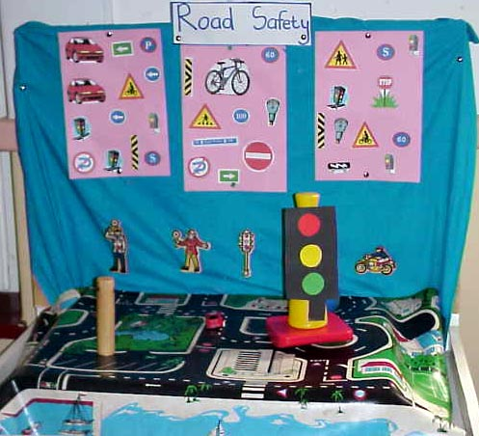

EARLY CHILDHOOD ENVIRONMENT RATING SCALE - REVISED (ECERS-R)
Statements of Developmentally Appropriate Practice
Space and Furnishings
1. Indoor space
Children need sufficient space that is well lit and has a comfortable temperature for learning and playing. Indoor space that is well maintained and in good repair sends a message to the young child that is welcoming and inviting.
2. Furniture for routine care, play and learning
Children need appropriate furnishings to meet the demands of their daily schedules. Basic furniture such as cots, tables and chairs should be sturdy and appropriate to the size of the children in the group in order for children to be comfortable, have proper body support, and focus on learning, playing, and routine activities rather than their own discomfort. Caregivers need easy access to routine care furnishings, such as cots, in order to maintain proper supervision and provide smooth transitions between activities.
3. Furnishings for relaxation and comfort
Children need space and opportunity to relax and rest. Soft furnishings and toys allow children opportunities for relaxation and comfort. Cozy areas provide a space for quiet activities to occur and should be protected from active play so children can snuggle, daydream and lounge.
4. Room arrangement
Creative room arrangement promotes a child's positive self-image and encourages a wide variety of age appropriate activities. Well-defined interest centers where materials are accessible help children to understand about organization and returning materials to their proper place.
5. Space for privacy
Some children experience unacceptably high levels of stress when exposed to constant activity and interaction. Places where children can escape from the pressures of group care promote positive self-esteem. Providing a child with opportunities, space, and time to be alone can contribute to positive classroom behavior.
6. Child related display
Every child needs to know that others value his/her play or work. Artwork or other individual work that is created by the children should be displayed in the classroom at the child's eye-level. This promotes feelings of positive self-esteem and sends the message to the child that his/her work is valued and appreciated.
7. Gross motor play
Children need daily opportunities to exercise large muscles, run in open spaces, and practice gross motor skills. (Safety is always a number one priority.) Space to develop children's large muscles through a variety of play experiences should be made safe by providing adequate cushioning for fall zones. All play equipment should be safe and effective monitoring should be implemented to teach children safe play behavior and to safeguard against accidents.
8. Gross motor equipment
Children need age appropriate stationary and portable equipment to promote a wide variety of skills that exercise large muscles while developing confidence and abilities. Equipment should be sound, sturdy, safe and accessible to children daily.
Personal Care Routines
9. Greeting/Departing
Parents and children need a warm, welcoming, and pleasant atmosphere to make the daily greeting and departing routine a happy one. Positive greetings help to promote the children's self-esteem and create a welcoming environment for parents.
10. Meals/Snacks
Meals and snacks that follow USDA guidelines contribute to the health of children and provide a model for good nutritional habits for life-long practice. Proper hand washing along with careful food preparation teach children proper hygiene and promotes sanitary conditions.
11. Nap/Rest
Nap and/or rest time should be appropriately scheduled and supervised for the children in the group. Adequate separation of cots helps to prevent the spread of germs. Soft music or a soothing story helps to facilitate a peaceful rest time that is important in helping children to balance the day and renew their energy.
12. Toileting/Diapering
Young children need appropriate supervision of the toileting process in order to care for basic needs and to teach the importance of good health habits. The schedule should be individualized. Provisions, such as soap and steps near the sink, should be convenient and accessible so that children can wash hands after toileting; this promotes self-help skills and good personal hygiene. Diapering should always be managed in a manner that promotes safety and good health practices.
13. Health practices
Practicing preventive measures, such as washing hands after handling pets or wiping noses, help to educate children to achieve life-long health practices. Taking appropriate action when children are sick will minimize the spread of germs.
14. Safety practices
Protecting children is critical in providing quality care, whether through adequate supervision or minimizing hazards both inside and outside. Caregivers should anticipate potential safety problems and demonstrate, model, and teach children safe practices.
Language-Reasoning
15. Books and pictures
The use of books and pictures is an important means of learning for children as they make sense of the world around them. Books, pictures, and language materials should be available in sufficient number both for independent use in a reading center and for use by a teacher with children in formal and informal settings.
16. Encouraging children to communicate
Activities and materials that promote language development should be available for use throughout the classroom and the daily schedule. Teachers should establish an environment where language exploration and usage is encouraged.
17. Using language to develop reasoning skills
Logical relationships and concepts should be presented in appropriate ways. Children learn through interaction with materials and people, both peers and adults, in the context of play and daily routines. Language provides the key tool for success and problem solving, as children are encouraged to talk through their thought processes.
18. Informal use of language
Language is a way for children to expand understanding. Caregivers should engage children in give and take conversations for enjoyment and learning. They should support child-to-child conversations as well.

Activities
19. Fine motor
Children need a variety of age-appropriate and developmentally-appropriate toys and materials that they can manipulate with their hands and play with at will. These activities strengthen fine motor control while encouraging skill development that contributes to academic readiness.
20. Art
Children benefit from exposure to child-initiated art activities that are open-ended and process oriented. Children's art should be respected and appreciated as individual, creative expression. Materials and opportunities to create art projects at a beginning and more advanced level should be available as children are developmentally ready for them.
21. Music/movement
Music and movement are valuable means of learning. Children need a supportive environment that includes a teacher and a variety of tools to encourage their self-expression through music and related activities.
22. Blocks
Block play, with a variety of blocks and accessories, allows children the opportunity to explore spatial, mathematical, and role-play possibilities. Powerful block play requires sufficient space in a protected area and time to expand on concepts and ideas.
23. Sand/water
Sand and water play gives children the opportunity to learn concepts through active exploration with their senses. The addition of interesting props extends the learning potential offered through sensory play.
24. Dramatic play
Dramatic play gives children the opportunity to discover an array of roles and responsibilities. It provides a vehicle through which they make sense of their world. Dramatic play is enhanced by space, time, props, materials, and supportive teachers.
25. Nature/science
Science and nature activities and materials foster curiosity and experimentation benefiting the young learner through direct experience and application to other areas of learning. Concept and observation skills are strengthened through science procedures.
26. Math/number
Math skills, when introduced through appropriate hands-on methods, form a foundation for school readiness and later academic success. Math skills can be taught effectively through routines, schedule, and play activities.
27. Use of TV, video, and/or computer
TV/video viewing and computer use tend to be passive in comparison to active involvement with materials and people. The use of each should be confined to subject material that is age-appropriate and mentally stimulating. Time limits encourage more active learning. Participation should not be required.
28. Promoting acceptance of diversity
Children need to be exposed to the similarities and differences of people in positive ways through books, pictures, toys, materials, and interaction. This exposure encourages respect for others and lessens misunderstandings.
Interactions
29. Supervision of gross motor activities
Caregivers should use gross motor activities as learning opportunities to promote positive social interactions and to encourage the development of skills and new experiences Diligent supervision of gross motor activities, whether indoors or outdoors, is critical to preventing accidents and insuring safe, active play.
30. General supervision of children (other than gross motor)
During activities, caregivers must balance the level of supervision and control based upon the ages, abilities, and individual needs of the children. Adequate supervision and awareness of the whole group is required for children's health and safety and in the recognition of accomplishments, which is necessary for children's emotional well-being.
31. Discipline
The set-up of the environment, teacher expectations, available materials and opportunities, and daily schedule significantly impacts children's behavior in childcare. A classroom and curriculum geared toward developmentally appropriate practice will lead to generally good behavior that is the product of self-motivation rather than the result of punishment and control.
32. Staff-child interactions
Caregivers, who are nurturing and responsive, promote the development of mutual respect between children and adults. Children, who trust adults to provide for their physical, psychological, and emotional needs, develop their own sense of self-worth and self-esteem.
33. Interactions among children
Because self-regulation, proper emotional expression, and positive social relationships are such essential skills for later schooling and life, teachers must encourage children to develop acceptable behaviors by providing a setting that encourages real opportunities for initiative taking and competence building. Providing opportunities for children to work and play together, to solve conflicts in productive ways, and to participate in group activities are ways teachers promote positive social relationships.
Program Structure
34. Schedule
Children thrive on having a consistent routine that provides a balance of activities designed to meet individual needs and foster physical, cognitive, social, and emotional growth. Best practice promotes a daily schedule with large amounts of time for play, smooth transitions between activities, and a balance between child-initiated and teacher-directed activities.
35. Free Play
When children are permitted to select materials and companions, and, as far as possible, manage play independently, they practice making decisions and having control of their world. Caregiver intervention should be in response to children's needs, an invitation, or an opportunity to expand play activities.
36. Group Time
In group-care situations, the focus needs to be on meeting individual needs and guiding children as they interact in small groups. Whole group activities should be kept to a minimum and limited to gatherings that follow the interests and involvement of the children.
37. Provisions for children with disabilities
Meeting the needs of children with disabilities requires knowledge of routine care needs, developmental levels, individual assessments, and the integration of the children in ongoing classroom activities. It also requires the involvement and establishment of a partnership between the parents and staff in setting attainable goals that will assist the child in reaching his/her full potential.

FORMATIVE ASSESSMENT

- IAC0102 Describe the different facilitation techniques in different learning contexts
- IAC0104 Explain the promotion of language development in relation to stories, books, songs, rhymes, fantasy, imaginative play and outdoors
- IAC0106 Explain the promotion of self-expression through creative art, movement, music and drama
- IAC0108 Explain the promotion of life skills through routines which promote independence and teacher-directed routines
- IAC0110 Explain how adults and families can contribute to and support learning
References

Active listening. http://en.wikipedia.org/wiki/Active_listening. Downloaded on 12 Aug 2008.

Brakefield-Caldwell, W. 2007. Community-Based Participatory Research &
Capacity building. http://en.wikipedia.org/wiki/Capacity_building Downloaded on 13 Aug 2008.

Collaboration Building. Published on http://rd100.cceb.med.upenn.edu/crcu_html/roadmap/mtgs/may_steering_2007/SP_McGranaghan_color.pdf Downloaded 5 Sept 2008.

Community development. 2007. Published on http://en.wikipedia.org/wiki/Community_development Downloaded 2 Sept 2008.

Dutschke, M. Children's rights to social services. Published on http://www.ci.org.za/depts/ci/enews/June2005/social_services.htm Downloaded on 15 Aug 2008.

Early Childhood Development practitioner training. Published on http://www.sasix.co.za/projects/view/ECD-KZN-FEB-0001/ Downloaded 3 Sept 2008.

Family And Marriage Society of South Africa Published on http://www.famsa.org.za/ Downloaded 8 Sept 2008.

http://www.ncrel.org/sdrs/areas/issues/educatrs/leadrshp/le300.htm Downloaded 2 Sept 2008.

McClure, R. 2007. Tips for a Successful Parent-Teacher Conference. Published on http://childcare.about.com/b/2007/05/16/tips-for-a-successful-parent-teacher-conference.htm Downloaded 8 Sept 2008.
Orans, L. P. 1996. What are values? Published on http://www.pinetreeweb.com/values.htm Downloaded 4 Sept 2008.
Appendices
All qualifications and part qualifications registered on the National Qualifications Framework are public property. Thus the only payment that can be made for them is for service and reproduction. It is illegal to sell this material for profit. If the material is reproduced or quoted, the South African Qualifications Authority (SAQA) should be acknowledged as the source.

SOUTH AFRICAN QUALIFICATIONS AUTHORITY

REGISTERED QUALIFICATION:

Occupational Certificate: Early Childhood Development Practitioner

SAQA QUAL ID | QUALIFICATION TITLE
97542 | Occupational Certificate: Early Childhood Development Practitioner
ORIGINATOR
Development Quality Partner - ETDPSETA (Education)
PRIMARY OR DELEGATED QUALITY ASSURANCE FUNCTIONARY |  |  | NQF SUB-FRAMEWORK
- |  |  | OQSF - Occupational Qualifications Sub-framework
QUALIFICATION TYPE | FIELD |  | SUBFIELD
Occupational Certificate | Field 05 - Education, Training and Development |  | Early Childhood Development
ABET BAND | MINIMUM CREDITS | PRE-2009 NQF LEVEL | NQF LEVEL | QUAL CLASS
Undefined | 131 | Not Applicable | NQF Level 04 | Regular-ELOAC
REGISTRATION STATUS |  | SAQA DECISION NUMBER | REGISTRATION START DATE | REGISTRATION END DATE
Registered |  | IEXC 0002/16 | 2016-02-17 | 2019-02-17
LAST DATE FOR ENROLMENT |  | LAST DATE FOR ACHIEVEMENT
2020-02-17 |  | 2023-02-17

In all of the tables in this document, both the pre-2009 NQF Level and the NQF Level is shown. In the text (purpose statements, qualification rules, etc), any references to NQF Levels are to the pre-2009 levels unless specifically stated otherwise.

This qualification does not replace any other qualification and is not replaced by any other qualification.

PURPOSE AND RATIONALE OF THE QUALIFICATION

Purpose:
The purpose of this qualification is to prepare a learner to operate as an Early Childhood Development Practitioner.
An Early Childhood Development Practitioner plans and prepares early childhood activities, facilitates and mediates learning, observes and assesses the progress of children, and reflects on learning in an inclusive, play-based environment to support holistic development of children (from conception - school going) in different centre-based or non-centre based settings.
A qualified learner will be able to:
• Plan and prepare broad-phase learning environment and stimulating activities that meet the holistic needs of all children in centre-based or non-centre-based settings.
• Facilitate and mediate all aspects of the daily programme in a centre-based or non-centre based setting.
• Observe, assess and record each child's progress according to the age and stage.
• Compile a report of each child's progress.
• Maintain and promote the well-being, health, nutrition, safety and protection of children.
Rationale:
The Occupational Certificate: Early Childhood Development has been designed to meet the needs and interests of the early childhood development sector in a variety of settings and contexts with an inclusive focus on education, health and safety issues, amongst others. There is a vast need for early childhood development services and it is critical that the field must be served by competent practitioners. In order to meet the needs at early childhood development level, it is important to be able to identify and recognise competent early childhood development practitioners who are able to work in centre-based and non-centre-based early childhood development settings.
This qualification will provide a means to give recognition to practitioners at an entry level, thus making it possible for practitioners to increase their employment prospects within the Department of Basic Education. The Department of Social Development, through the registration of early childhood development centres and/or sites, may also provide business opportunities to successful practitioners who may wish to establish early childhood centres and/or sites. It will also provide access to a recognised career path and at the same time provide the field with suitably qualified professional practitioners.
The qualification will provide opportunities to people who wish to enter and/or continue learning in the early childhood development field, which include the employed, under-employed but not qualified, and school leavers. Every child has the right to high-quality, holistic education and care which forms the critical foundation for further development and learning from childhood into adulthood.
This necessitates the universal availability of high-quality early childhood development and education as a vital strategy to yield personal and long-term benefits to individual children, their families and the society at large.
Early childhood development is an essential component of economic development within the framework of child care services. Changing social and economic needs require parents to enter the labour market. Therefore quality early childhood development service provision is required to meet growing demands in the country, both in urban and rural settings.

LEARNING ASSUMED TO BE IN PLACE AND RECOGNITION OF PRIOR LEARNING

Recognition of Prior Learning (RPL):
RPL for access to the external integrated summative assessment: Accredited providers and approved workplaces must apply the internal assessment criteria specified in the related curriculum document to establish and confirm prior learning. Accredited providers and workplaces must confirm prior learning by issuing a Statement of Results or certifying a Work Experience Record.
RPL for access to the Qualification: Accredited providers and approved workplaces may recognise prior learning against the relevant access requirements.
Entry Requirements:
• National Certificate Vocational (NCV) at NQF Level 3.
Or
• Any other NQF Level 3 qualification.

RECOGNISE PREVIOUS LEARNING?

Y

QUALIFICATION RULES

This qualification is made up of the following compulsory Knowledge Modules, Practical Skill Modules and Work Experience Modules totalling 131 Credits:
Knowledge Modules: 43 Credits:
• 234201000-KM-01, Introduction to the early childhood development sector, at NQF Level 4, 4 Credits.
• 234201000-KM-02, Theories and Perspectives of Child Development, at NQF Level 5, 6 Credits.
• 234201000-KM-03, Planning and Programme Development in early childhood settings, at NQF Level 4, 8 Credits.
• 234201000-KM-04, Facilitation and mediation of active learning, at NQF Level 5, 12 Credits.
• 234201000-KM-05, Observation and assessment in early childhood development, at NQF Level 4, 4 Credits.
• 234201000-KM-06, Promotion of health, safety and well-being of children, at NQF Level 4, 6 Credits.
• 234201000-KM-07, Administration for early childhood development services and programmes, at NQF Level 3, 3 Credits.
Practical Skill Modules; 43 Credits:
• 234201000-PM-01, Plan and prepare inclusive educational activities and routines using an approved programme based on the curriculum framework, at NQF Level 4, 12 Credits.
• 234201000-PM-02, Facilitate and mediate active learning in an integrated and holistic learning programme, at NQF Level 5, 9 Credits.
• 234201000-PM-03, Observe, assess, record and report each child's progress according to the age and stage, at NQF Level 4, 4 Credits.
• 234201000-PM-04, Support and promote the health, nutrition, safety, protection and well-being of children, at NQF Level 4, 12 Credits.
• 234201000-PM-05, Build and maintain collaborative relationships with parents and other service providers, at NQF Level 4, 3 Credits.
• 234201000-PM-06, Prepare and maintain administrative systems, at NQF Level 3, 3 Credits.
Work Experience Modules; 45 Credits:
• 234201000-WM-01, Learning programme and routines planning and preparation process, at NQF Level 4, 13 Credits.
• 234201000-WM-02, Processes of facilitating and mediating the learning programme in a variety of contexts, at NQF Level 4, 15 Credits.
• 234201000-WM-03, Processes of observation, assessment, recording and reporting on children's learning and development, at NQF Level 4, 7 Credits.
• 234201000-WM-04, Processes and procedures of promoting the health, nutrition, safety, protection and well-being of children in an early childhood development setting, at NQF Level 4, 10 Credits.

EXIT LEVEL OUTCOMES

1. Plan and prepare broad-phase learning environment and stimulating activities that meet the holistic needs of all children in centre-based or non-centre-based settings.
2. Facilitate and mediate all aspects of the daily programme in a centre-based or non-centre based setting.
3. Observe, assess and record each child's progress.
4. Compile a report of each child's progress.
5. Maintain and promote the well-being, health, nutrition, safety and protection of children.

ASSOCIATED ASSESSMENT CRITERIA

Associated Assessment Criteria for Exit Level Outcome 1:
• In inclusive physical learning environment for the selected broad phase is set up to encourage play, exploration and learning for all children in a centre-based or non-centre-based setting.
• The concepts of inclusion, diversity, equality, cultural and language sensitivity in early childhood development are explained in accordance with legal and centre policy requirements.
• A daily plan for one broad phase that reflects diversity, culture and inclusivity is designed and developed using developmentally appropriate activities, resources and equipment.
• The activities are planned and prepared, and resources are adapted to meet the learning and developmental needs, including special needs, of a selected broad phase within the planned programme.
• Factors to be considered when planning for the learning and development of children in a centre-based or non-centre-based setting are identified and explained.
Associated Assessment Criteria for Exit Level Outcome 2:
• The importance and benefits of both indoor and outdoor play are explained with examples.
• Types of play that support the areas of learning and development are identified and analysed as outlined in the early childhood development curriculum.
• A daily plan for one broad phase is implemented using appropriate activities and resources that reflect diversity, culture and inclusivity.
• Reasons why both adult-directed and child-initiated play and learning activities are important for children are explained, in relation to development and learning of children.
• The needs of all children in a centre-based or non-centred-based setting are identified and mediated through interactions, communication, guidance and care.
• The facilitation of child-initiated and adult-directed activities is demonstrated.
• The development of children's language and thinking is mediated through integrated activities using different methods.
• Barriers to play-based learning in an early childhood development setting are identified and described with examples.
Associated Assessment Criteria for Exit Level Outcome 3:
• The importance of observing, assessing and documenting children's learning and development in a centre-based setting is explained.
• Different assessment techniques appropriate to early childhood development are identified and explained in order to assess the child's development and learning.
• Different methods for gathering information of children's development and learning are identified and described with examples.
• Different methods for recording children's learning and development are identified and described with examples.
• Possible factors which may impede children's progress are identified and explained with examples.
• Relevant tools, templates and documentation are used to produce written evidence of observation and assessment that meets the criteria for sound assessment practices of one child, using.
• Observation and assessment methods to detect warning signs of developmental, emotional or health-related problems, including special needs, are applied, and findings are interpreted and recorded using relevant templates.
• Child's records that meet the centre's policy requirements are completed.
Associated Assessment Criteria for Exit Level Outcome 4:
• Observation and assessment records are evaluated to determine children's developmental milestones and possible individual differences that affect children's growth and development.
• The achievement of learning goals and targets is reviewed to track children's progress.
• A progress report is developed integrating all relevant information pertaining to the child's progress, with recommendations in accordance with centre reporting requirements.
• A plan is developed using assessment results to shape learning opportunities and needs of children, to achieve positive outcomes.
• The importance of working with families to develop strategies with children when there are behavioural concerns is explained in order to promote positive behaviour.
• Information gathered about children's progress is analysed, interpreted and used to support individual's development and learning, and to inform practice.
Associated Assessment Criteria for Exit Level Outcome 5:
• Different types of accidents and emergency situations which may occur in an early childhood development setting are identified and described.
• An action plan on how to respond to accidents and emergency situations is developed in accordance with health and safety legislation and regulations, and the centre's policy requirements.
• The nutritional requirements of a healthy diet for children are outlined by means of a weekly menu for all children, taking into account special dietary requirements.
• Techniques of promoting healthy lifestyles for babies and children are identified and described with examples.
• Given a case scenario, the signs of distress, maltreatment, abuse or neglect are identified and described, and recommendations on how to deal with them reflect centre policies in terms of rules of confidentiality and reporting procedures, including legal requirements.
• Environmental dangers, infections and risks that may affect children, including children with special needs, in the centre-based or non-centre-based setting, are identified and explained with examples.
• Procedures for recording and reporting accidents and other emergencies in own setting are described in accordance with legal and centre policy requirements.
• Measures for the prevention and spread of infection in early childhood development settings are identified and described in accordance with legislation, regulations and guidance that apply to infection prevention and control.
Integrated Assessment:
Integrated formative assessment:
The skills development providers will use the curriculum to guide them on the stipulated internal assessment criteria and weighting. They will also apply the scope of practical skills and applied knowledge as stipulated by the internal assessment criteria. This formative assessment leads to entrance into the integrated external summative assessment.
Integrated Summative Assessment:
An external integrated summative assessment, conducted through the relevant QCTO Assessment Quality Partner, is required for the issuing of this qualification. The external integrated summative assessment will focus on the Exit Level Outcomes and Associated Assessment Criteria.

INTERNATIONAL COMPARABILITY

The aim of the international comparability study was to examine early childhood development qualifications of other countries at international, regional and African contexts to benchmark best practice in this field. The study examined occupationally-based early childhood development qualifications and related curricula, including competencies as standards of knowledge and skills of early childhood development professionals responsible for the care and education of children at different levels. The comparability exercise focused on three countries, namely United States of America, United Kingdom and Kenya.
The findings of the study indicate that the sections on training and qualifications of Early Childhood Education (ECE) staff in ECE centres differ markedly in terms of duration and levels of study.
United States of America:
The US Delaware Department of Education identified competencies of early childhood professionals and divided the ECE staff into four levels. Level 1 practitioners are required to assist, Level 2 to implement, Level 3 to design and develop, and Level 4 to manage and lead. All staff is required to have knowledge and skills in the following content areas:
• Child Development.
• Environment and Curriculum.
• Promoting socio-emotional development.
• Observation and assessment.
• Health, Safety and Nutrition.
• Working with Families and Professionalism.
These content areas are identifiable in the countries compared, which are the United Kingdom and Kenya with professionalism and legislation/policy frameworks and reflective practice being used interchangeably, diversity or inclusion being highlighted, and aspects of qualification design, qualification evaluation, context-specific interventions, children's welfare, specific focus areas of language, etc. and activities fore-grounded in the qualifications offered, comparing favourably with the South African early childhood development outcomes.
United Kingdom:
Course Title: CACHE Level 3 Childcare and Education:
This is a work-based, competence-based qualification that prepares learners to work with children and young people with their families in a variety of settings. The job roles are listed as follows:
• Child-minder.
• Crèche Leader.
• Nursery Nurse.
• Nursery Supervisor.
• Playgroup Leader.
• Pre-school Leader.
• Special Educational Needs Supporter.
• Toy Library Leader.
The competencies reflect the skills and knowledge needed to do a job effectively; to work on their own initiative, planning and organising their own work; and supervising others. This qualification is pitched at the level equivalent to the South African Occupational qualification developed for ECD Practitioners.
The qualification structure is as follows:
• Unit 1: An introduction to working with children.
• Unit 2: Development from conception to age 16 years.
• Unit 3: Supporting children.
• Unit 4: Keeping children safe.
• Unit 5: The principles underpinning the role of the practitioner working with children.
• Unit 6: Promoting a healthy environment for children.
• Unit 7: Play and learning in children's education.
• Unit 8: Caring for children.
• Unit 9: Development of professional skills within children's education.
The CACHE Level 3 Diploma in Early Years Education and Care (Early Years Educator) prepares learners to become Early Years Educators, enabling them to work with children from birth to 5 years and gain knowledge of children aged 5 to 7 years.
Kenya:
GEMS Training Education and Leadership Academy:
Title: CACHE Level 3 Diploma for the Early Years Workforce (Early Years Educator) (QCF).
Early Childhood Development Education in Kenya is under the care of parents, community, non- governmental organisations (NGO), religious organisations and other private providers. In Kenya the Nursery Teacher Certificate course (2 years) is replaced by the KHA (Kindergarten Teacher Diploma) for low-budget private pre-schools that serve low-income families. Further to this there is little information available about ECE staff that works out of centres such a playgroup facilitators, home-visitors or toy librarians. The search indicated that the mostly used education and training in early childhood development for practitioners is offered through GEMS Education in partnership with CACHE (Council for Awards in Care, Health and Education). GEMS Education is providing globally recognised Early Years Practitioner accredited qualifications in sixteen countries in the world. The CACHE Level 3 Diploma for the Early Years Workforce (Early Years Educator) (QCF) prepares learners to become Early Years Educators, enabling them to work with and care for children from birth to 5 years and gain knowledge of children aged 5 to 7 years. It is a work-based qualification that recognises effective practice by assessing the skills, knowledge and understanding of practitioners, including child development, teaching methods and appropriate provision for young children.
The units are structured around four themes as follows:
• Unit 1: Health and well-being.
• Unit 2: Legislation, frameworks and professional practice.
• Unit 3: Play, development and learning for school readiness.
• Unit 4: Professional development.
The duration of the full diploma is 12 months and it is offered through online and classroom sessions (face-to-face) during six weekend training workshops spread throughout the year. Although the mode of delivery varies with this qualification, the course content and duration compare favourably with the occupational qualification.
Conclusion:
The findings of the research done in the countries above reveal that the Early Childhood Development Practitioner Occupational Qualification compares favourably with that of the countries studied. There are many similarities in terms of the scope, content and duration of the qualification.

ARTICULATION OPTIONS

Horizontal Articulation:
• Further Education and Training Certificate in Early Childhood Development, NQF Level 4, SAQA ID: 58761.
Vertical Articulation:
• National Certificate in Early Childhood Development, NQF Level 5, SAQA ID: 58761.
• National Diploma in Early Childhood Development, NQF Level 5, SAQA ID: 64650.

MODERATION OPTIONS

N/A

CRITERIA FOR THE REGISTRATION OF ASSESSORS

N/A

NOTES

Qualifying for external assessment:
In order to qualify for the external summative assessment, learners must have a copy of a completed and signed Statement of Work Experience as well as proof of successful completion of the following subjects and Modules or Alternative Programmes where applicable:
Foundational Learning Competence is a pre-requisite for access to the external integrated summative assessment.
Additional legal or physical entry requirements:
None
Criteria for the accreditation of providers:
Accreditation of providers will be done against the criteria as reflected in the relevant Curriculum on the QCTO website.
The Curriculum Title and Code is: 234201000: Early Childhood Development Practitioner.
This Qualification covers the following trades as recorded on the NLRD:
• Not applicable as this Qualification is not a trade.

LEARNING PROGRAMMES RECORDED AGAINST THIS QUALIFICATION:

NONE

PROVIDERS CURRENTLY ACCREDITED TO OFFER THIS QUALIFICATION:

This information shows the current accreditations (i.e. those not past their accreditation end dates), and is the most complete record available to SAQA as of today. Some Primary or Delegated Quality Assurance Functionaries have a lag in their recording systems for provider accreditation, in turn leading to a lag in notifying SAQA of all the providers that they have accredited to offer qualifications and unit standards, as well as any extensions to accreditation end dates. The relevant Primary or Delegated Quality Assurance Functionary should be notified if a record appears to be missing from here.

NONE

All qualifications and part qualifications registered on the National Qualifications Framework are public property. Thus the only payment that can be made for them is for service and reproduction. It is illegal to sell this material for profit. If the material is reproduced or quoted, the South African Qualifications Authority (SAQA) should be acknowledged as the source.

